**Psychiatric Genetic Counseling Module**

**Facilitator Guide**

Contents

Introduction 5

Flipped Classroom Approach: One way to go through the module 6

Objectives 8

ACGC Standards (v. 10.1.19) 8

Psychiatric Genetic Counseling 9

Definitions 9

Genetic Counseling 9

Psychiatric Genetic Counseling 9

Mental Illness 9

Psychiatric Conditions 9

Main Papers 11

Lecture 12

Clinical Application of Psychiatric Genomics (Clinical Application of Psychiatric Genomics) presented by Angela Inglis (Translational Psychiatric Genetics Group) 12

Simulated Session 13

Simulated Session Video 13

Facilitator Simulated Session Guide 13

Role Plays 16

Things to have the students thinks about: 16

Scenarios 17

Observer Guide 22

Case Based Learning Example 23

Case-based Learning Example Facilitator guide 23

Quiz 42

Quiz Questions 43

Quiz Questions with Answers and Justifications 47

Resources 53

Jar model slide deck 53

Mental Illness – Underlying Causes and Approaches to Recovery 53

22q11.2 Deletion Syndrome: What Does it Mean for Mental Health? 53

Discussion 54

Stigmas 54

Stigmas video 54

Stigmas Paper: 54

Supplemental Material 55

Patient/Client Resources 55

The Orchid Article 55

The Ulysses Agreement 55

https://www.bcss.org/family-advocacy/ulysses-agreement/ 55

Supplemental Empiric Risks and Genetic Counseling Resources 56

Empiric Risk Resource 56

Empiric Risk Tables 56

Anxiety Disorders Risks Table 56

Addiction Risks Table 56

Psychiatric Genetics Glossary 56

Mental Health Service Roles 56

Supplemental Readings 57

How to Talk with Families About Genetics and Psychiatric Illness (Book) 57

Ethical Issues Associated with Genetic Counseling in the Context of Adolescent Psychiatry 57

Genetic Counselors’ Attitudes Toward and Practice Related to Psychiatric Genetic Counseling 57

Outcomes of Psychiatric Genetic Counseling in Relation to Time Since Diagnosis and Symptom Onset 58

Patient Perspectives on the Process and Outcomes of Psychiatric Genetic Counseling: An “Empowering Encounter” 58

Psychiatric Disorders in Clinical Genetics II: Individualizing Recurrence Risks 59

Psychiatric Genetic Counseling for People with Copy Number Variants Associated with Psychiatric Conditions 59

Relationships Between Patient- and Session-Related Variables and Outcomes of Psychiatric Genetic Counseling 59

Training to Provide Psychiatric Genetic Counseling: How Does It Impact Recent Graduates’ and Current Students’ Readiness to Provide Genetic Counseling for Individuals with Psychiatric Illness and Attitudes Towards This Population? 60

Supplemental Podcasts and Presentations on PGC 61

Genetic Counseling: Key to the Genomics Revolution (2017 - Future of Genomic Medicine - Jehannine Austin) 61

The Genetics of Bipolar Disorder: Causes, Risks, and Testing 61

Supplemental Information on Genetic Testing and Psychiatric Disorders 62

Genetic Testing and Psychiatric Disorders – A Statement from the International Society of Psychiatric Genetics 62

Anticipating the Ethical Challenges of Psychiatric Genetic Testing 62

Clinical Genetic Counseling and Translation Considerations for Polygenic Scores in Personalized Risk Assessments: A Practice Resource from the National Society of Genetic Counselors 62

Appendix 1 – Practice Based Competencies 63

ACGC Practice-Based Competencies (2015) 63

CBGC Practice-Based Competencies 64

# Introduction

This educational module was created as a part of genetic counseling graduate student Colton Rathbun’s capstone project at the University of North Carolina Greensboro with the help of Prescilla Carrion, Rachel Mills, Heewon Lee, and Jehannine Austin, all of whom are genetic counselors with expertise in psychiatric genetic counseling, education/pedagogy, or both. Educational materials from members of the National Society of Genetic Counselors Psychiatric Special Interest Group and Translational Psychiatric Genetics Group (University of British Columbia) were collected and compiled, and new materials created by the research group were added. Within this module, you will find:

* objectives and standards that the module is designed to achieve,
* primary literature articles regarding psychiatric genetic counseling,
* a two-hour pre-recorded lecture with slides included,
* a simulated session with a question guide,
* role play scenarios,
* a case-based learning exercise,
* quiz questions,
* visual aids and informational resources,
* and other supplemental materials.

These materials are intended to help educate current genetic counseling graduate students. The suggested path to use for navigating this module takes a flipped-classroom approach. However, the module has been designed so that it can be used in the way that makes the most sense and is the most beneficial to your program and students.

Please be aware that the quiz questions are only in the facilitator guide and not accessible to students without your permission. Feel free to use these questions in whatever assessment form you prefer. Be aware that these questions are the same that are being used by other programs as well, so students should not share questions or answers with other students, even from other programs.

# Flipped Classroom Approach: One way to go through the module

The flipped classroom approach is one way to use the materials within the module. The flipped classroom approach allows the students to study the material independently before class by way of lecture, reading, etc., and allows in class time to be dedicated to discussion and practice of the concepts. Graduate students like the flipped classroom approach and demonstrate better motivation, engagement, increased learning, and effective learning. If you would like to use this approach, we suggest the following path:

Prior to Class (~2 ½ hours), have the students:

* Watch the two-hour lecture entitled “Clinical applications of psychiatric genomics: Applying genetic counseling to improve outcomes for people with psychiatric disorders and their families” presented by Angela Inglis
* Review the two primary papers:
  + Austin, J. C. (2020). Evidence-Based Genetic Counseling for Psychiatric Disorders: A Road Map. *Cold Spring Harbor Perspectives in Medicine*, *10*(6), a036608. https://doi.org/10.1101/cshperspect.a036608
  + Peay, H. L., Veach, P. M., Palmer, C. G., Rosen‐Sheidley, B., Gettig, E., & Austin, J. C. (2007). Psychiatric disorders in clinical genetics I: Addressing family histories of psychiatric illness. *Journal of Genetic Counseling*, *17*(1), 6–17. <https://doi.org/10.1007/s10897-007-9120-5>

During Class (2 ½ - 3 hours)

* Discuss any questions the students may have had while watching the lecture or from the papers
* Watch the simulated session entitled “Psychiatric genetic counseling – A simulated patient session recording” and use the discussion guide included beginning on page 12 in this Facilitator Guide to pause and discuss
* Have the students break up into groups of three and practice roles plays or go through the case-based learning example
* If time permits, watch the video on stigmas and open discussion about stigmas the students may have

After class

* Provide the students with the quiz questions for them to answer as assessment.

**Reference**

Nouri, J. (2016). The flipped classroom: For active, effective and increased learning – especially for low achievers. *International Journal of Educational Technology in Higher Education.* 13(33).https://doi.org/10.1186/s41239-016-0032-z

# Objectives

* Describe psychiatric genetic counseling in comparison to other specialties
* Describe common psychiatric conditions that can have a significant genetic risk component
* Identify and respond to counselor stigmas associated with psychiatric conditions
* Employ genetic counseling strategies to perform a psychosocial assessment and elicit a family history specific to psychiatric conditions
* Explain the multifactorial nature of psychiatric conditions
* Utilize and explain the jar model to facilitate understanding of underlying causes and protective strategies for mental health
* Provide a personalized risk assessment, including personalizing estimated values for recurrence risks of psychiatric conditions

# ACGC Standards (v. 10.1.19)

* B2.1.1a Principles of human genetics/genomics: Mendelian and non-mendelian inheritance
* B2.1.1d Principles of human genetics/genomics: Family history and pedigree analysis
* B2.1.2a Principles of genetic counseling and clinical genetics: Clinical features and natural history of a broad range of genetic diseases, complex common disorders and syndromes of unknown etiology
* B2.1.2c Principles of genetic counseling and clinical genetics: The process for managing a case in the context of different genetic counseling specialties, including but not limited to: preconception, prenatal, pediatrics, general genetics, cancer, cardiology, neurogenetics, genomic medicine, and laboratory genetic counseling
* B2.1.2i Principles of genetic counseling and clinical genetics: Risk assessment
* B2.1.3f Psychosocial content: Psychosocial assessment
* B2.1.6c Education: Delivery and evaluation of educational tools and materials

# Psychiatric Genetic Counseling

## Definitions

### Genetic Counseling

“The process of helping people understand and adapt to the medical, psychological, and familial implications of the genetic contributions to disease. This process integrates:

* Interpretation of family and medical histories to assess the chance of disease occurrence or recurrence.
* Education about inheritance, testing, management, prevention, resources and research.
* Counseling to promote informed choices and adaptation to the risk or condition.” (Resta et al., 2006)

### Psychiatric Genetic Counseling

Psychiatric genetic counseling for conditions such as schizophrenia, bipolar, eating disorders, depression, anxiety—like genetic counseling for any other conditions—seeks to help people make personal meaning of the factors that contribute to the development of the condition that they have or that runs in their family (Resta et al. 2006).

“Psychiatric Genetic Counseling: helping people to better understand what it is that we know from research about the causes of psychiatric disorders, about how genes and environment can work together to contribute to the development of these conditions, and it’s about providing support and counseling for people around that to address any guilt or shame or stigma that they might be feeling. In addition, what we can also do is talk to people about strategies they might be able to use to protect their mental health going forward.” - Jehannine Austin (Austin, 2015).

Psychiatric Genetic Counseling is defined as a specialist health discipline that involves using information gathered from the client to personalize the provision of evidenced based information about causes of psychiatric disorders (genetic and environmental), chances to develop these conditions, and strategies to promote mental health (Carrion et al., 2023).

### Mental Illness

Mental illnesses are health conditions involving changes in emotion, thinking or behavior (or a combination of these). Mental illnesses can be associated with distress and/or problems functioning in social, work or family activities. (American Psychiatric Association, 2023)

### Psychiatric Conditions

#### Anxiety disorders

Excessive fear or anxiety

* Most common mental disorder
* Affect ~30% of people

#### Bipolar disorders

“Brain disorder that causes changes in a person’s mood, energy, and ability to function” (American Psychiatric Association, 2023)

* Experience intense emotional states
  1. Manin/hypomanic - abnormally happy or irritable mood
  2. Depressive – sad mood

#### Depressive disorders

“Causes feelings of sadness and/or loss of interest in activities once enjoyed” (American Psychiatric Association, 2023)

#### Obsessive compulsive disorder

“Recurring, unwanted thoughts, ideas or sensations” (American Psychiatric Association, 2023)

* Feel driven to do something repetitively

Schizophrenia

“Can include delusions, hallucinations, disorganized speech, trouble with thinking, and lack of motivation” (American Psychiatric Association, 2023)

**Reference**

American Psychiatric Association. (2023). *DSM-5 fact sheets*. Psychiatry.org - DSM-5 Fact Sheets. <https://www.psychiatry.org/psychiatrists/practice/dsm/educational-resources/dsm-5-fact-sheets>

Austin, J. (2015, April 14). *What is psychiatric genetic counseling?* [Video]. https://www.youtube.com/watch?v=PqnxqMnPk_g

Carrion, P., Austin, J., Elliott, A. (2023). A Genetic Counselor’s Reflections on Lessons Learned, Challenges, and Successes Experienced during a One-Year Pilot Integration in a Primary Care Clinic. *Public Health Genomics,* 26 (1), 58–67. <https://doi.org/10.1159/000530683>

Resta, R., Biesecker, B. B., Bennett, R. L., Blum, S., Estabrooks Hahn, S., Strecker, M. N., & Williams, J. L. (2006). A new definition of genetic counseling: National Society of Genetic Counselors’ Task Force Report. *Journal of Genetic Counseling*, *15*(2), 77–83. <https://doi.org/10.1007/s10897-005-9014-3>

# Main Papers

Austin, J. C. (2020). Evidence-Based Genetic Counseling for Psychiatric Disorders: A Road Map. *Cold Spring Harbor Perspectives in Medicine*, *10*(6), a036608. https://doi.org/10.1101/cshperspect.a036608

Abstract:

Psychiatric disorders, such as schizophrenia, depression, anxiety, and bipolar disorder, are common conditions that arise as a result of complex and heterogeneous combinations of

genetic and environmental factors. In contrast to childhood neurodevelopmental conditions

such as autism and intellectual disability, there are no clinical practice guidelines for applying

genetic testing in the context of these conditions. But genetic counseling and genetic testing

are not synonymous, and people who live with psychiatric disorders and their family

members are often interested in what psychiatric genetic counseling can offer. Further, research shows that it can improve outcomes like empowerment for this population. Despite

this, psychiatric genetic counseling is not yet routinely or widely offered. This review describes the state of the evidence about the process and outcomes of psychiatric genetic

counseling, focusing on its clinical implications and remaining research gaps

Peay, H. L., Veach, P. M., Palmer, C. G., Rosen‐Sheidley, B., Gettig, E., & Austin, J. C. (2007). Psychiatric disorders in clinical genetics I: Addressing family histories of psychiatric illness. *Journal of Genetic Counseling*, *17*(1), 6–17. <https://doi.org/10.1007/s10897-007-9120-5>

Abstract:

This is the first article of a two-part professional development series addressing genetic counseling for personal and family histories of psychiatric disorders. It is based on an Educational Breakout Session presented by the Psychiatric Special Interest Group of the National Society of Genetic Counselors at the 2006 Annual Education Conference. This article examines issues that arise in addressing family histories of psychiatric illness, while the second article in the series considers the generation and provision of individualized recurrence risks for psychiatric disorders. In this article we discuss the importance of managing uncertainty for affected individuals and their close family members who have been referred to genetics for a number of different indications. We then use four simulated cases to make recommendations about the scope and timing of discussions related to the psychiatric family history.

# Lecture

## Clinical Application of Psychiatric Genomics ([Clinical Application of Psychiatric Genomics)](https://www.youtube.com/watch?v=hpFap1zY-Rc) presented by Angela Inglis (Translational Psychiatric Genetics Group)

This is a pre-recorded lecture that is about two hours and three minutes long. This lecture can be watched in one sitting before or during class. It can also be broken into two parts by watching the first part before class individually (59 minutes and 30 seconds) and the second part during class together. The Lecture video and PowerPoint slides are on Padlet for student access. Personal notes are included below for just the facilitators.

https://www.youtube.com/watch?v=hpFap1zY-Rc

*These materials are available under a CC BY-NC-ND license. This means that others are allowed to reuse and distribute the work in an unadapted form for non-commercial purposes; neither commercial use or adaptation is allowed. Attribution to the work's creators (Jehannine Austin and Anegla Inglis) must be provided.*

* Lecture objectives:
  + Describe common psychiatric disorders
  + Review current knowledge in psychiatric genetics/genomics
  + Understand the importance of understanding cause of illness for people with psychiatric disorders and their families
* Highlights from topics discussed:
  + What is mental illness and how common it is?
  + Treatment and recovery
  + Psychiatric genetic research
  + Environmental risk factors
  + Perceptions of cause: feelings and behavior
  + How to start the conversation of psychiatric conditions
  + Explaining the etiology of psychiatric disorders
  + Pregnancy considerations
  + Risks of developing a psychiatric condition

# Simulated Session

There is a pre-recorded hour-long simulated session facilitated by Jehannine Austin for a family history of psychiatric conditions. The students can watch this simulated session independently and pause and reflect/answer the questions at the points designated on the student guide, or this can be watched together as a group, and you can pause and discuss together at the designated points. The facilitator notes are only visible to you as the facilitator to help guide your discussion and ensure that certain points are addressed. If you view the simulated session in class, it is expected to take about an hour and a half to complete due to watching the video and discussing.

## Simulated Session Video

<https://www.youtube.com/watch?v=NSLIdczmzZM>

*These materials are available under a CC BY-NC-ND license. This means that others are allowed to reuse and distribute the work in an unadapted form for non-commercial purposes; neither commercial use or adaptation is allowed. Attribution to the work's creators (Jehannine Austin, Katie Cardiff, and Morgan Kauffman) must be provided.*

## Facilitator Simulated Session Guide

*Points in italics are for the facilitator specifically.*

**Pause at 9:30 to discuss contracting and background**

1. Was there anything that surprised you?

*Facilitator notes: Ensure the group identifies that the counselor collected information about what the patient understood about the etiology of psychiatric conditions, and discusses how often they do this/have seen this in rotations. Then raise the following questions:*

* 1. What benefits do you see in collecting this information during contracting?
  2. What limitations or downsides are there to collecting this information during contracting?

*Facilitator notes: E.g., benefits: can make the session more patient centered, limitations: perception that it “takes longer”, have to remember what patient says.*

1. What did you think about the information that was provided about what genetic counseling is at the beginning of the session?

*Facilitator notes: Was there anything different about the way in which the purpose of the appointment was presented from the way you do this/the way you have seen this done in rotations? E.g., the counselor presented GC as helping to understand genetics of psychiatric conditions and what we can do to help with the psychiatric conditions going forward.*

**Pause at 23:53 to discuss family history**

1. What were your thoughts about how the family history was prefaced to be tailored towards PGC?

*Facilitator notes: It was prefaced to be about psychiatric conditions and*  *questions were geared towards gathering more detailed information about those*  *conditions as they came up.*

1. What did you notice about how the family history/pedigree was used?

*Facilitator notes: The patient was able to see the pedigree image and make statements off of what she saw.*

*The patient gave a lot of information on what this picture means to her and what she is afraid of occurring in the future.*

**Pause at 37:30 to talk about counseling and jar model so far**

1. How would you use the jar model in your own sessions?

*Facilitator notes: At what time do you feel that the jar model is beneficial to begin*  *using in a session to help explain concepts and what may be happening in the*  *family history?*

1. Did you notice clear distinctions between information giving and counseling?

*Facilitator notes: There was not a clear distinction between the two. The counselor provided counseling as they presented the information and had frequent check-ins.*

1. What did you think about how validation was provided?

*Facilitator notes: Validation was used to help the patient feel like her thoughts*  *and fears are valid, and that there are still things that we can do to help*  *ourselves even with a strong family history or previous life choices that may* *not have been positive for our mental health.*

**Pause at 51:48 to talk about protective factors**

1. What did you notice about how the discussion of protective factors evolved?

*Facilitator notes: Different protective factors work better or worse or are feasible for some and not others. The protective factors need to be tailored to the patient.*

**End of video**

1. What did you think about the suicidality check-in?

*Facilitator notes: ensure that the discussion of this question includes: a) whether participants feel that this fits within our scope of practice as genetic counselors (it does), b) What do you do if someone says they are harming themselves (follow the set protocol by your organization; example protocol provided), and c) whether asking about suicide increases the risks of suicide attempts (there is lots of data demonstrating that it does not – in fact quite the opposite seems to be true).*

**Overall thoughts**

1. At what point do you feel like rapport was established?
2. What did you notice about how pronouns and sex and gender were discussed in the session?
3. Was there anything that stood out to you that may be harmful to the patient?
4. What would you have done differently?
5. Did you notice the counselor doing self-disclosure? What were your thoughts on this and was it appropriate?
6. To what extent did you feel the session was similar to or different from sessions you do/have observed? What were the similarities and differences, and what value do you think the differences have? How should what you observed be changed to be more like what you do/have seen, or vice versa?
7. How did the session embody the values that we have within the field of genetic counseling (or not)?

*Facilitator notes: ensure participants discuss the extent to which the genetic counselor embodied “non-directiveness”, what this means, and whether being “directive” is “bad” or appropriate. (e.g. Once the patient said a protective factor they wanted to work on, the genetic counselor was directive on how to achieve that goal.)*

**Personal reflection**

1. What impact do your prior experiences with psychiatric conditions have on your thoughts towards PGC?
   1. Are there topics that would be difficult for you to discuss because you have personally faced them or had a bad counseling experience?
2. What personal stigmas might you have towards PGC?
   1. How would you counter this so as to provide the best counseling for your patients?

# Role Plays

There are five role play scenarios for the students to practice in pairs or small groups. You may consider creating groups of three and assigning each group three different role play scenarios. Within each group, assign one person as the genetic counselor, one person as the patient, and one person as the observer who takes notes. Within the Padlet module, there are three different documents corresponding to each role the student takes on. The “genetic counselor” needs to only review the role play scenario document; The “patient” needs to review the role play scenario with extra information (the bulleted points); And the “observer” needs to review the observer guide and take notes. Then they can switch roles and practice a different scenario. The pedigree keys are included in the facilitator guide to ensure accuracy.

## Things to have the students thinks about:

1. What level of detail do you need when contracting?
2. What questions would you ask during the pedigree taking to elicit the psychiatric family history specifically?
3. How can you explore the patient’s ideas of how psychiatric conditions develop?
4. How can you validate the patient’s thoughts and feelings about psychiatric conditions?
5. What stigmas or pre-conceived judgements do you need to be aware of when doing a PGC session?

## Scenarios

1. You are seeing a 40-year-old cisgender man. His father was diagnosed at 25 with schizophrenia. The patient is concerned about developing schizophrenia and wants to know his risk so that he can start planning next steps for his husband and children.

* The patient’s father died at 70.
* The patient’s father has two brothers and a sister. One of the brothers is deceased but was diagnosed with a “psychiatric condition” at age 30. The other brother and the sister died of old age with no known mental health concerns in their 80’s.
* The patient’s paternal grandparents died of old age. The paternal grandfather had PTSD.
* The patient’s mother had depression throughout life, but it was controlled with low doses of medication (Prozac).
* The patient’s mother had two sisters. One sister had depression as well, but it was also controlled with low doses of medication (Prozac).
* The patient doesn’t know anything about the maternal grandparents.
* The patient is in a same-sex marriage. He and his husband went through IUI to conceive their two children using his sperm. The surrogate had no mental health concerns for herself or her family.
* The patient has a son and a daughter, both in their 30’s, with no known mental health concerns.

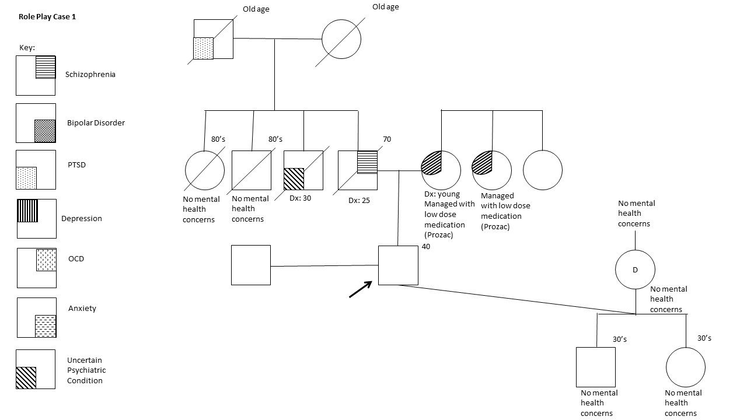

1. You are seeing a 16-year-old cisgender girl with severe depression. Per the medical records, her mother has depression, and her father has bipolar disorder. Her PCP writes that she said, “no matter what I do, I’m just going to be sad because it’s a part of me and in my family”. Her PCP has referred her to psychiatric genetic counseling to discuss the risks of developing bipolar disorder and to discuss her depression.

* She has a 20-year-old sister who does not have any signs of a psychiatric condition.
* She has a brother who is 18 years old who has bipolar disorder.
* Her mother had a brother who died at 22 by suicide.
* The patient’s maternal grandmother had depression, but they never really talked about it.
* The patient’s maternal grandfather “had something, but we never figured it out”
* The patient’s father has three sisters, none of whom have a known psychiatric disorder.
* The patient’s paternal grandfather and grandmother do not have a known psychiatric disorder.
* The patient stays in her room most of the time and doesn’t hang out with friends.
* The patient is up very late into the night, even on school nights.
* The patient uses Lexapro for her depression, but stops taking her meds every few months because she feels that they just aren’t helping.

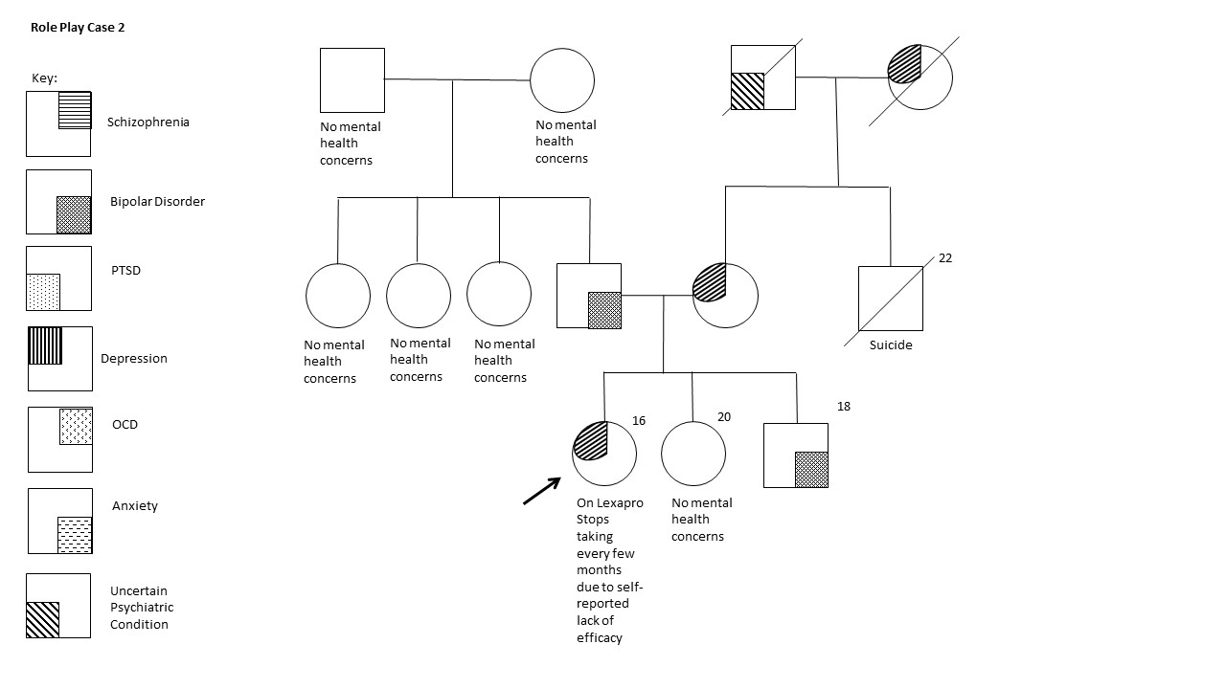

1. You are seeing a 33-year-old cisgender woman in the perinatal office. She currently has a daughter from a previous partner. Her current partner, a cisgender man, has severe OCD and depression with a strong family history of depression. She has always wanted more children, but she is scared of having a child with a psychiatric condition because of how she has seen it affect her current partner and his family. She is coming to you for pre-conception counseling for psychiatric disorders.

* The patient has mild anxiety that is treated with medication (Prozac).
  + - The patient has a daughter who is 4 from a prior partner, and she does not have any symptoms of any psychiatric disorders.
    - The patient’s previous partner has severe depression and no known family history of mental illness.
    - The patient’s mother did not have any psychiatric disorders. She had two sisters, each with mild anxiety.
    - The patient’s father had OCD and was an only child.
* The patient’s current partner grew up in a very strict household that required him to keep the house clean at all times. His family also does not believe in getting help for mental illness.
  + - His sister and father have depression per the husband, although they will not talk about it.
    - None of his father’s siblings have any known psychiatric disorders.
    - His mother has depression. Her sisters also have depression.

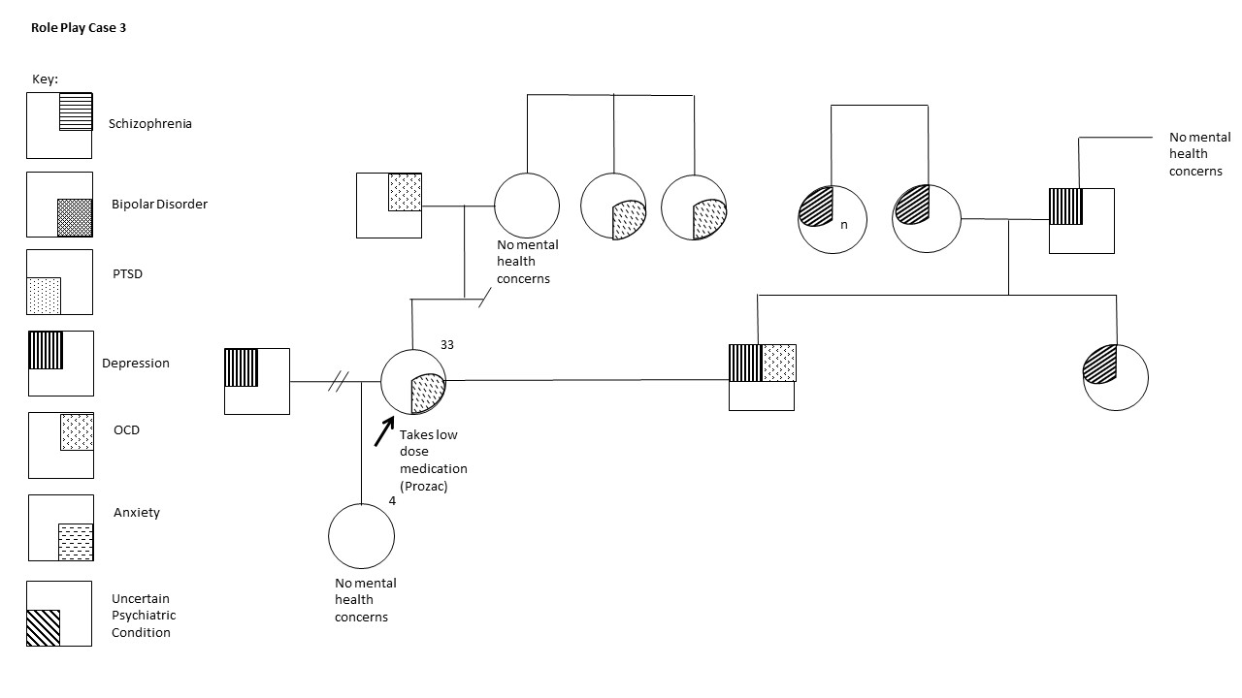

1. A patient who is a 23-years-old transgender female is coming to see you following a referral by her PCP for discussion of severe depression. Per the PCP note, she repeatedly stops taking her medication (Zoloft) and will not seek therapy.

* The patient had a daughter at 17 while in high school with her then girlfriend.
* The patient is in a relationship with a woman.
* The patient has a history of marijuana and alcohol use problems
* The patient comes from a very religious family
* The patient has a brother and a sister who are 16 and 17 respectively. The sister does have some sort of mental health concern and was in a psychiatric hospital for two weeks a year ago for a suicide attempt. The patient says that it is because her sister’s boyfriend broke up with her. The brother does not have any known mental illness.
* The patient says that their mother is very “temperamental” and hard to talk to. She doesn’t have any mental health concerns, but she knows that her mother takes medications for something.
* The patient’s mother has a sister who died by suicide at age 30.
* The patient’s maternal grandmother has depression.
* The patient’s maternal grandfather does not have any known psychiatric conditions.
* The patient’s father does not have any mental health concerns. He is adopted and does not know anything about his family history except that his biological mother had high anxiety.

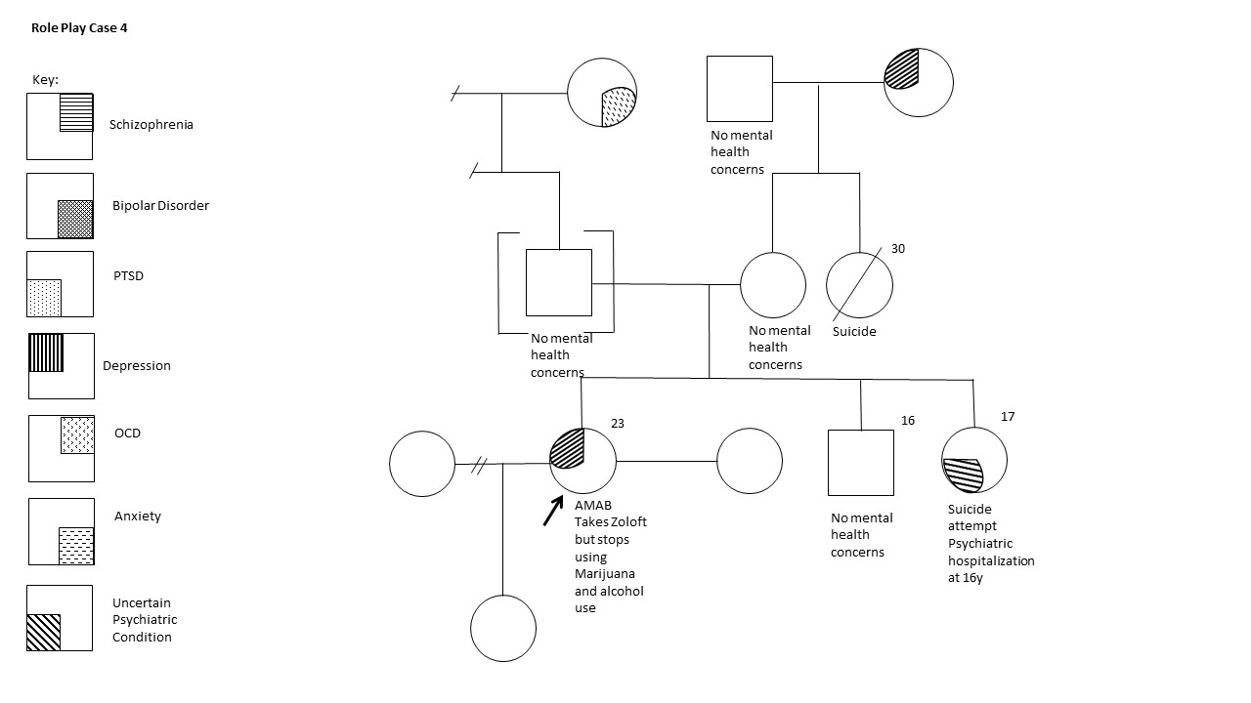

1. A patient is referred to you by their PCP for anxiety disorder. The patient is a transgender man who is 42 years old and wants to do genetic testing to determine why he has such bad anxiety.

* The patient is married to a cisgender man.
* Together, they have two sons, using their own gametes. One is 15 and one is 17.
* The patient is worried about his oldest son, as he is beginning to become more anxious about his homework and where to go to college.
* The patient has an older brother and a younger sister, both of whom have anxiety.
* His brother has two daughters, both in their mid 20’s, who do not have known psychiatric concerns.
* His sister has a son and daughter, both around the same age as the patient’s sons, and neither have known mental health concerns.
* The patient’s mother had anxiety.
* The patient’s mother had three brothers, all of whom do not have known mental health concerns.
* The patient’s father had OCD and was an only child.
* The partner of the patient does not have any known mental health concerns.
* His partner is an only child.
* His partner’s mother has anxiety. She has two sisters who have anxiety.
* His partner’s father has no known mental health concerns. He has two sisters who do not have any known mental health concerns.

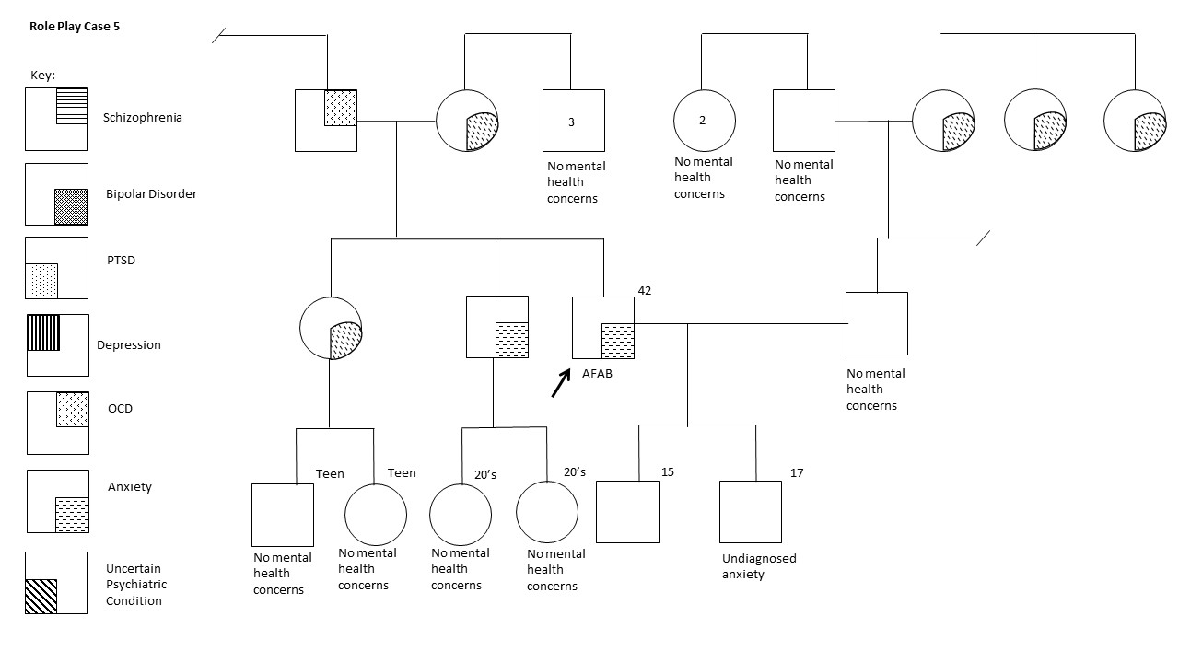

## Observer Guide

1. How did the genetic counselor help to make the patient feel comfortable and build rapport to talk about psychiatric conditions?
2. How did the genetic counselor address the patient’s misconceptions about the genetics of psychiatric conditions?
3. How did the genetic counselor address negative feelings the patient may have experienced, such as guilt, shame, etc.?
4. Did the genetic counselor provide validation and support?
5. Did the genetic counselor show any signs of stigmas associated with psychiatric conditions or use words that could be taken as judgmental?
6. Did the genetic counselor utilize the jar model appropriately and in a way that the patient could understand and follow along?
7. Additional comments:

# Case Based Learning Example

This case-based learning example is a scenario for you to go through as a class. It is expected to take about 1 to 1.5 hours to complete. The information provided here is for the facilitator to use to help guide the conversation. The guide provided on Padlet is for the students and includes only the scenario information and questions, not the bolded information.

*These materials are available under a CC BY-NC-ND license. This means that others are allowed to reuse and distribute the work in an unadapted form for non-commercial purposes; neither commercial use or adaptation is allowed. Attribution to the work's creator (Jehannine Austin) must be provided.*

## Case-based Learning Example Facilitator guide

**The following pages are for the use of the group facilitator only.**

The facilitator's job is to guide participants through the case, ensuring that the participants' time is spent discussing topics that address the objectives of the case.

You do not need to be a subject matter expert to facilitate a group discussion, but familiarity with the content of the facilitator guide before starting is highly recommended.

The facilitator should encourage discussion amongst group members and should step in to redirect only when necessary. The notes outlined in these pages should help you to achieve that. The case could be completed in 1 hour, but the timing is very tight - more time is better - 1.5 hours is more optimal. If you are aiming to do this in one hour - paying close attention to the time allocated in the facilitator guide for each sheet is critical!

The facilitator should share the pages for participants one at a time, with each new page only presented once the group has addressed all of the relevant questions from the previous page. The facilitator should ask a member of the group to read aloud each new page that they present.

**Samantha Smith**

|  |
| --- |
| You are a genetic counselor working in direct patient care; your next patient is Samantha Smith, a 42-year-old woman who has Bipolar Disorder (BD). She has been seen and treated by her family physician for about 20 years. The referral notes say that she has been treated with Lithium since being diagnosed with BD at 21. She is married and has one daughter (21), and has a very high-powered job at a local company, at which she has excelled despite having to take time off work during periods when she feels more depressed – the company is aware of her mental health problem and supportive of her (even writing articles about her in their company newsletter). But the referral notes indicate that she is frustrated and unsatisfied because poor mental health is affecting her work. Her BMI is 33, and she has poorly managed sleep apnea. The appointment has been made because she has had some genetic testing that the physician does not know how to interpret.    On arriving she tells you that she is thrilled to see you – an expert in genetics – because she hopes that you can help her understand what her test results mean because she is having a hard time making sense of it. |

READING THIS PAGE ALOUD, LOOKING AT EXHIBIT 1, AND ANSWERING

THE QUESTIONS ON THIS PAGE should take 10 minutes (1 min to read, 4 mins discussing feelings, 2.5 mins each discussing sleep apnea and genetic testing).

**PRESENT EXHIBIT 1: 23andMe genetic test results for BD (next page)**

*Question: What is your immediate reaction to/how do you feel about her request and why?*

*Question: What would you want to know from Samantha about the genetic testing?*

Explore how the students feel about addressing genetic testing for psychiatric disorders and where this comes from.

Participants may express the desire to go away and research the background for the test that Samantha had. You can inform them that this kind of testing is easy to access. People can upload their raw genetic test data from companies like 23andMe or Ancestry.com into any one of a variety of 3rd party websites that will produce data like this. Don't let this conversation continue too long! If needed, prompt them to step back and think about this from the perspective of the situation at hand - help them if needed to say that we know that psychiatric disorders are complex conditions that arise as a result of genes and environment acting together. Polygenic risk scores (PRS) for psychiatric disorders including BD account for less than 10% of the overall liability for the condition.

In sum, this means that the test result has minimal clinical utility.

**SHARE WITH THEM THE NEXT PAGE OF THE CASE!**

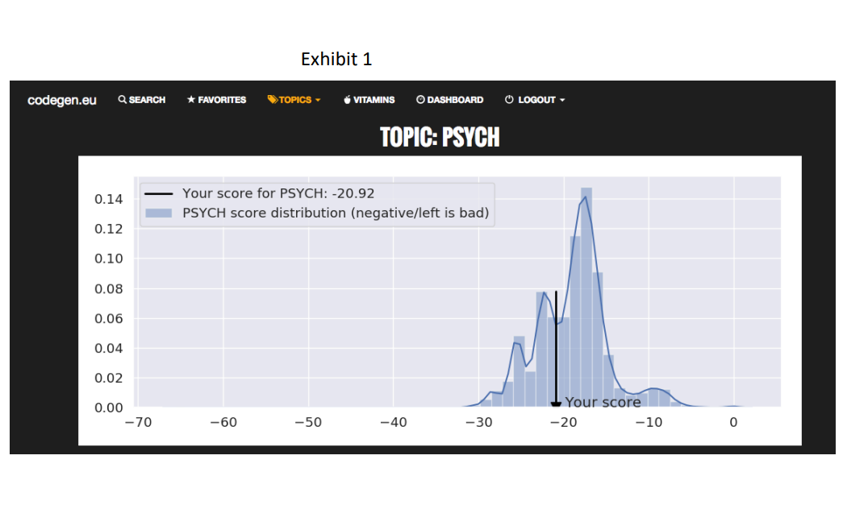

|  |
| --- |
| Samantha says she got genetic testing because she wanted to give the information to her daughter because she too would soon develop the same condition. But now she is really confused by the test results she got – she was expecting that the results would tell her that she has a 100% chance to develop BD, because she has already been diagnosed with the disorder. But that’s not what the results say. |

#### READING THIS PAGE ALOUD, AND ANSWERING THE QUESTION ON THIS PAGE should take 10 minutes (1 min to read, 9 mins discussing question).

*Question: What questions do you need to ask?*

If it doesn't happen spontaneously, help the participants identify that they need to understand:

What she means by saying that her daughter will soon develop BD.

What she understands about the causes of BD - and encourage participants to think about how they would elicit this. What would they do if they ask directly and she says she doesn't know? What if they ask, and her response is: "Just genetics"? Would they go any further? Try to get them to suggest asking something like: "what was going on for you around the time you first got sick?" this is a really good way to initiate identification and discussion of environmental factors that may have contributed to onset.

Whether there is any family history of mental illness. Again, encourage the participants to think about *how* they would elicit family history of mental illness. It is not sufficient just to ask, "Does anyone have mental illness?" Multiple approaches are helpful because people think about it differently. If they don't come up with these example questions themselves, offer them as possibilities: "Did anyone in the family receive a diagnosis of something like (GIVE EXAMPLES) depression, anxiety, OCD?", "Did anyone seem to have dramatic mood swings?", "Was anyone ever hospitalized for mental health reasons?", "Did anyone have a nervous breakdown?", "Did anyone attempt suicide?"

When they are finished discussing how they would elicit family history, you can provide the family history information. Try to keep this quick. Simply tell them that there is no family history of mental illness aside from a single episode of postpartum depression in Samantha's mom. If for some reason they desperately need more info (please don't encourage this, it detracts from the point), give them the following:

Samantha and her husband (44) have one child only (21). Her husband has no mental health problems and no family history of mental health problems among his 4 sisters and aging parents, neither of whom have siblings. All of Samantha’s husband’s grandparents died in their 80s, his maternal grandmother had a "nervous breakdown" after delivering Samantha, but aside from that there are no mental health problems.

Samantha has one brother (36) who has two young daughters (2 and 4), her parents have no known experience with mental health problems aside from a brief bout of depression for Samantha's mom after delivering Samantha's brother.

Samantha's parents each have one brother, no known mental health problems amongst their kids or the grandparents.

|  |
| --- |
| You ask Samantha about what she means by saying her daughter will develop BD soon.    She tells you that she herself developed BD at 21, and as her daughter just turned 21, she is certain to develop BD any day now, and this is something Samantha is extremely anxious about.    You ask Samantha what she understands about the causes of her BD.    She tells you that she knows BD is genetic, and this leads her to wonder aloud if somehow her sample or results got mixed up with someone else’s, and she received the wrong ones. Alternatively, she wonders whether the test results mean that she does not in fact have BD, and whether – if this is the case - she can stop taking her medications? You tell her that those are really important topics that you can discuss with her, but first, you ask if there was anything else that she thinks might have played a role in the symptoms of her illness starting, and she answers with an unequivocal “no”. But you decide to explore possible environmental factors further, asking instead about what was going on for her around the time she was first diagnosed with BD. She becomes emotional and tells you a long list of highly stressful life events (death of a parent, personal physical injury in a car crash, best friend diagnosed with cancer, miscarriage) that occurred in rapid succession over a period of 6 months before her initial diagnosis.    You ask about family history of mental illness.    Samantha reports that aside from her mom who – she thinks - experienced one brief bout with depression, there was none. She now wonders out loud about that, and suggests in a half-joking manner that perhaps she is adopted, or her father is not biologically related to her, after all she must have inherited it from somewhere….. |

#### READING THIS PAGE ALOUD, LOOKING AT EXIBIT 2, AND ANSWERING THE QUESTIONs ON THIS PAGE should take 10 minutes (1 min to read, 9 mins discussing question).

*Question: What issues do you need to address?*

Get the participants to identify that they need to address the following issues, they should refer back to the previous page:

That the test results do not mean that she does not have BD, and that this does not mean that she should stop her lithium.

Her lack of biological family history of BD does not mean that she is adopted/there is non-paternity/that they have mixed up the test results.

It is not a certainty that her daughter will develop BD - the specific risk number is not relevant to clinical care at this time - the key/fundamental issue is that it is not a certainty.

*Question: What is the point of asking about family history here?*

Encourage participants to say that:

It is important to understand her experience of psychiatric illness in her family, and that if there were multiple other family members who were affected, it may have helped to explain why she feels that BD is genetic. The fact that there is no family history is interesting given her belief that genetic factors have caused BD.

Family history can be used as a tool to have an individualized discussion based on her own personal and family history, and about how genes and environment both contribute to the development of these conditions.

It allows the genetic counselor/clinician to calculate recurrence risks if necessary. If the participants want to talk about what the actual numbers are, explore with them whether numbers and risk estimates are of the highest importance here. If they don't get to it themselves, suggest that this is NOT the most important aspect of this particular appointment. It may help her to be told that the chance for her daughter to develop BD is not 100%, but perhaps that's all she needs to know, and the specific figure is not as important. Remind participants that not all patients will actually want to know specific risk numbers. But as you have spoken with Samantha, it has become clear that there are other concerns that need to be addressed, and that it is important for her to understand more than just the risk number to address these other issues. If participants still want to discuss recurrence risk, point out that this is not one of the questions they have been asked to address at this point in the activity. But if participants are unable to move on, the chance for the daughter to develop BD would be around 15% based on her family history. Tell them that we can discuss this at the end.

**PRESENT EXHIBIT 2 (on following pages)**

Encourage participants to consider and discuss how its genes and environment acting together, and how that relates to the genetic test that she had, her lack of family history. Guide them to recognize (tell them if necessary) that it is very common for there to be no family history among people with psychiatric disorders. Encourage participants to discuss how that is compatible with the jar model explanation of the etiology of mental illness - if they don't get there themselves, tell them that just because no other family members have been affected, this doesn't mean that they had no genetic vulnerability to mental illness. Based on existing evidence, it seems likely that we all have some genetic vulnerability to mental illness, we just vary individually in how much. So, if there is no-one else in the family who has experienced psychiatric problems, this is indicative that the “jars” of those family members were not filled all the way to the top.

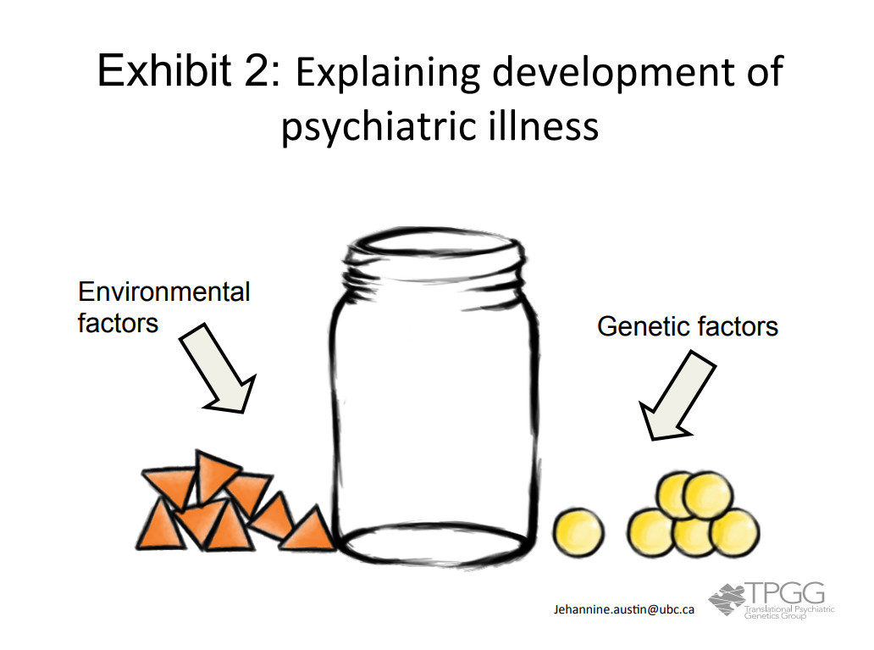

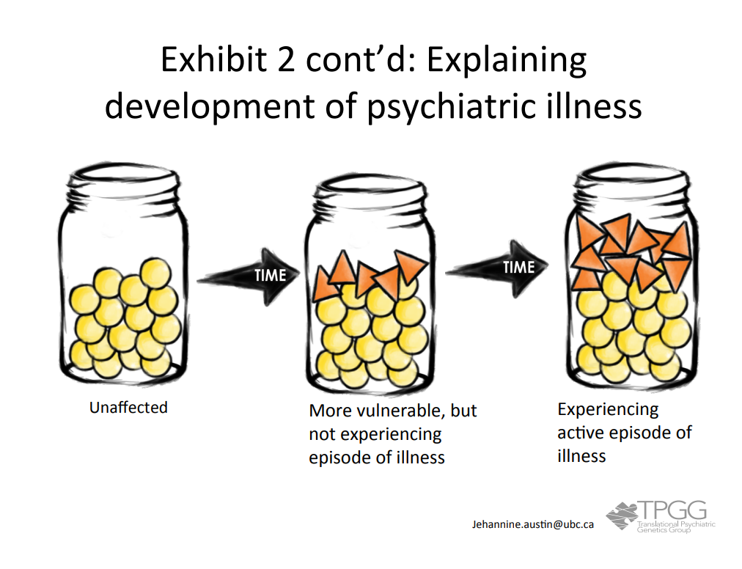

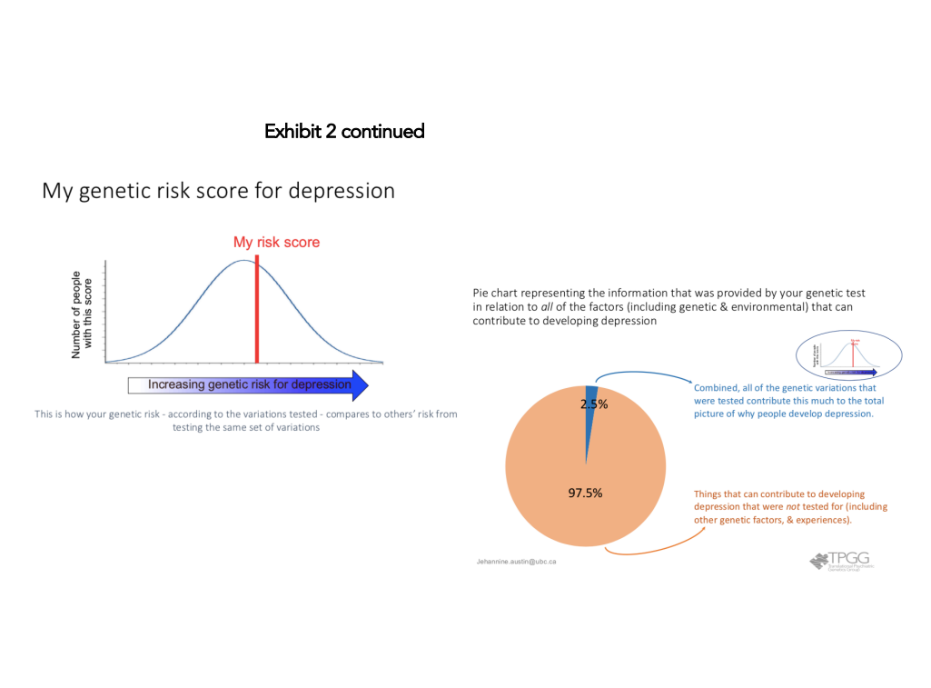

|  |
| --- |
| You tell Samantha that the test result does not mean that they mixed up samples or that she doesn’t have BD, and it doesn’t mean that she should stop taking her medication. You tell her that her lack of family history of BD does not mean that she is adopted or that her father is not biologically related to her.  You tell her that it is far from a certainty that her daughter will develop BD. You start explaining for her that we don’t typically inherit mental illness itself but we can inherit a vulnerability to mental illness.    You use the jar model (Exhibit 2) to illustrate for Samantha what we know about how BD is caused by a combination of genes and environment acting together. You tell Samantha that there are likely to be all sorts of different types of genetic variations that people can have that will make them more vulnerable to developing BD, and that this genetic test that she got only looked at one type of genetic difference. You talk about how everyone likely has some genetic vulnerability to mental illness, and that the reason no-one else in her family is affected is that they were lucky enough not to experience those life events that would fill the jar to the top.    Samantha smiles and nods and says she understands.    You are about to change gear, and ask her about how she is doing with her mood before moving to wrap up the appointment, but because you have a small uncomfortable feeling, you ask Samantha about the main thing that she took away from the discussion. Samantha tells you that she understands that the test she had just didn’t look at enough genes to provide the correct information. She says that she does in fact have a 100% chance for developing BD (because she has it), and that her daughter will develop it soon, too. |

READING THIS PAGE ALOUD, AND ANSWERING THE QUESTION ON THIS PAGE should take 6 minutes (1 min to read, 5 mins discussing question).

*Question: What do you think happened here?*

*Question: And what do you do now?*

Maybe Samantha didn't understand (you were not clear enough) or maybe her understanding of the cause as genetic is very important for her psychologically for some reason. Encourage participants to identify the root of Samantha’s misunderstanding (e.g. to her, it means that she is not culpable). But the concern with Samantha maintaining genetic etiology is that she might be doing little to protect her own mental health (remind participants that Samantha’s mental health is currently poor, time off work etc), that she is so anxious about her daughter. As such, there would be some benefits to shifting Samantha’s belief about genetic etiology, particularly if you can help her to see that environmental vulnerability does not necessitate culpability.

Encourage participants to say that they would try again using different words - saying the key messages explicitly - and using examples of things she has shared with you to illustrate points.

|  |
| --- |
| You try again. You use new words to reiterate that BD is not caused by genes alone. You discuss how research shows that BD seems to be caused by both genes and environment acting together. You use the jar model to show Samantha how the stressful life events she experienced in the run-up to her diagnosis could have contributed environmental vulnerability factors to her jar. As you do so, you notice her face glazing over, and her color draining. |

READING THIS PAGE ALOUD, AND ANSWERING THE QUESTION ON THIS PAGE should take 3 minutes.

*Question: What do you think could be going on?*

*Question: What do you do to address this?*

She could be bored and nauseous for unrelated reasons, it could be that she doesn't understand and is feeling overwhelmed with it, or she could be horrified because of the reasons discussed on the last page. Guide participants to indicate that they would just ask her what is going on!

|  |
| --- |
| You ask Samantha what is going on. She tells you that she is horrified to think that people know that she has BD now that she sort of understands that its not just genetic. She says that she would never have told anyone about her diagnosis had she known it was anything other than genetic in origin, for fear that people would blame her for her illness. |

#### READING THIS PAGE ALOUD, AND ANSWERING THE QUESTION ON THIS PAGE should take 6 minutes.

*Question: How do you feel?*

*Question: How do you respond?*

The participants are likely feeling anxious and possibly guilty that they have removed a belief system for someone in such a way as to leave her feeling vulnerable. They may be unsure what to do now and worried that they have done harm. Remind them that we thought about this before doing it, and there were reasons for doing so - poor mental health, concern for her daughter etc.

Guide participants to say that they would explore where this belief comes from and to explain to Samantha that the things that happened to her were no-one's fault, certainly not hers.

|  |
| --- |
| You ask Samantha about where this idea comes from – she tells you that no, she has not heard anything from others that would make her think this is how they would react, but she believes it to be true.    You try to talk with her about how just because and illness is not entirely genetic does not mean that someone is culpable, and you tell Samantha gently but firmly that no-one could justifiably blame her for the stressful life events she described that preceded the onset of her symptoms.    She remains glazed and visibly upset, and blocks any further attempts to pursue this topic. |

READING THIS PAGE ALOUD, LOOKING AT EXHIBIT 3 AND ANSWERING THE QUESTIONS ON THIS PAGE should take 8 minutes (1 min to read, 7 mins discussing question).

*Question: How would you proceed?*

*Question: What is the danger in finishing the session now?*

*Question: Is there any other strategy that you could try to use to try to show Samantha the positive side of the information you’ve given her?*

Get the participants to think about whether they would finish or continue the session. The danger is that you’ve essentially opened a can of worms for her, it’s not right not to make a decent effort to try to help her realize the benefits of this pain that were the reason for getting into this in the first place. Ask the participants to imagine that they do have the flexibility of time to continue. They could talk with her about the implications of BD not being entirely genetic for her daughter, and how that might affect her positively: relief that it's not a done deal that her daughter will have BD, things she can do to protect her own and her daughter’s mental health

How could you use Exhibit 3 to help here?

**PRESENT EXIBIT 3 (on next page)** and get participants to think about helping her see that there are strategies she could use to protect her own mental health and that of her daughter, so that she has to take less time of work for being depressed – this is something she would value.

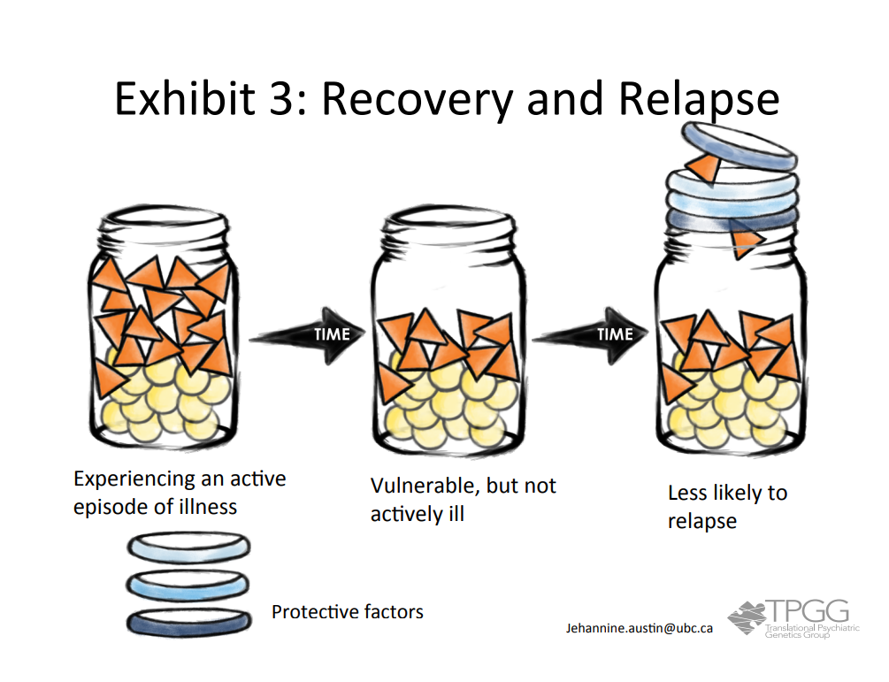

|  |
| --- |
| You talk with Samantha about the certainty she expressed that her daughter would develop BD too, and about how now that she knows that this condition arises as a result of genetics and environment acting together, this means that the chance for her daughter to develop BD is NOT 100%, and that there may be things that they can do to promote her daughter’s mental health. She nods and seems to cheer a little.    You take the opportunity to talk with her about her own frustration with taking time off work for mental health reasons, and explore with her what she does to take care of her mental health. She tells you that beyond taking her Lithium every day, she doesn't feel that she does much. You talk with her about the recovery aspect of the jar model, and explain that if she accepts that there is more to the etiology of BD than genetics alone then perhaps there is more that could be done to help protect her mental health in addition to using psychotropic medications. You talk with her about cognitive behavioral therapy, and about how finding some better strategies for managing her sleep apnea could help her mood stability. You also discuss how the balance between exercising and eating regular healthy meals, along with feeling guilty about not being “perfect” in these regards can be tricky. Through all of this she says little. As you are now way over the time you had available for the appointment, you initiate closing the session, as she leaves your office she tells you, backwards over her shoulder, that had she and her husband known that the chance for children to be affected was <100%, they would have had more children, bursts into tears, and dashes out. |

READING THIS PAGE ALOUD, AND ANSWERING THE QUESTION ON THIS PAGE should take 6 minutes.

*Question: How would you feel after an encounter like this?*

*Question: How would you manage it?*

Guide participants to talk about peer supervision for self-care, plans for follow up with the patient etc.

Epilogue

|  |
| --- |
| One month later, Samantha is doing better psychiatrically than she has since her initial diagnosis with BD. She has a psychiatrist for the first time, who is trying some new medication strategies with her which already seem to be helping her more than the lithium did. She has bought into the need to address her sleep apnea as, on reflection, she was able to see for herself how her mood was most unstable after periods of very unsettled sleep. She is going for a walk every day, and is trying to do more to eat healthily – so far, she has lost 5 kg (11 lbs). She and her daughter have just signed up for a mindfulness training series together. |

*Question: What do you think might happen if someone attributes their BD entirely to environmental factors, rather than genetics?*

Discuss how people can feel huge guilt if they feel their illness is entirely their own fault, and how if people think their illness is entirely attributable to environmental factors, then taking medication is not logical- they just need to try harder. The key is helping people to see that it is BOTH, while empowering them to feel they have some control, but not ultimate culpable responsibility.

# Quiz

There are twelve quiz questions available to the students on Padlet. The version included in this document includes the correct answer and justification, which the students do not have access to. Feel free to use these assessment questions following the lecture. Question eleven is not included within the lecture slide deck and may be a good question if you want the students to research outside of the lecture but would not be something they may know without outside research. The questions are included below, with the questions and the justifications/answers on the next page. Feel free to copy and paste these questions into the assessment form that you plan to use. Please know that these questions are the same questions being given to other programs, so students are not to share questions or answers with other students, even from other programs.

*These materials are available under a CC BY-NC-ND license. This means that others are allowed to reuse and distribute the work in an unadapted form for non-commercial purposes; neither commercial use or adaptation is allowed. Attribution to the work's creator (Caitlin Slomp) must be provided.*

## Quiz Questions

Genetic Counseling for Psychiatric Conditions

Created by Caitlin Slomp (Translational Psychiatric Genetics Group, UBC)

1. A 44-year-old cis-gendered woman comes to you self-referred for genetic counseling. Her husband was diagnosed with schizophrenia as a teenager, and their eldest child (a son) is approaching the age at which her husband was diagnosed. She is very concerned about his chance of developing schizophrenia. There is no other family history of mental illness. Based on current studies, what would you estimate her son’s chance is of developing schizophrenia?
   1. 2 – 7%
   2. 7 - 16%
   3. 15 – 17%
   4. 20 – 35%
   5. 40 – 50%
2. Although not yet widely used clinically, how can pharmacogenetic testing be used in the management of psychiatric conditions?
   1. Deciding whether to prescribe medication or talk based therapy
   2. Determining chance of manifesting symptoms
   3. Providing more accurate estimate of the chance of recurrence
   4. Predicting response to medications
   5. Ascertaining utility of non-biologic treatment
3. Because mental illness is a multifactorial (or “complex”) condition, it is crucial to take a thorough history, including pregnancy, birth and childhood history, to determine what environmental factors may have played a role in the development of mental illness. What environmental factor can have almost the equivalent impact of a first-degree relative on the relative chance for developing mental illness?
   1. Head injury
   2. Immigration
   3. Obstetrical complications
   4. Urban upbringing
   5. Winter birth
4. A same-sex male couple is referred to you following the birth of their son with a cleft lip and a heart defect. They opt to undergo genetic testing, and he is found to have 22q11.2 deletion syndrome. During your counseling session, you discuss the increased chance of psychiatric conditions among those with this diagnosis. Specifically, approximately what percentage of individuals with 22q11.2 deletion syndrome develop schizophrenia?
   1. < 10%
   2. 10-15%
   3. ~25%
   4. ~50%
   5. > 50%
5. When counseling patients about psychiatric conditions, it is critical to understand a patient’s beliefs surrounding the etiology of their condition to ensure you can tailor the session to their needs. What challenge might a patient face if they solely attribute their mental illness to their upbringing, without recognizing the genetic contribution?
   1. They may feel there is no point in engaging in strategies that might help protect their children’s mental health
   2. They may consider their children to be at very high chance - or genetically "destined" - to develop bipolar disorder.
   3. They may have decided not to have children based on their fear of passing on their genetic vulnerability to them.
   4. They may feel guilty for potentially having "passed on" their bipolar disorder to their children through their genes.
   5. They may not be engaging in all forms of treatment and/or protective factors that may be beneficial for them.
6. A 40-year-old transgender man comes to you for genetic counseling due to a family history of psychiatric illness. He is concerned because he has a close family member who has been diagnosed with bipolar disorder. Based on current studies, having which family member affected would put him at highest chance of developing bipolar disorder, major depression or schizoaffective disorder?
   1. Child
   2. Cousin
   3. Parent
   4. Grandparent
   5. Uncle
7. A 25-year-old non-binary person whose mother has been diagnosed with depression comes to you self-referred for genetic counseling.  A close friend told them that psychiatric illness can “run” in families and suggested that they request the “Polysomething Risk Score test” to better understand their chance for developing depression.  How would you best explain the current utility of Polygenic Risk Scores (PRS) in psychiatry?
   1. PRS are starting to be used in the clinic to determine age of onset for mental illness.
   2. PRS can explain a significant position of a person’s genetic chance for a mental illness for those patients of European descent.
   3. A PRS at the 99th percentile confers an equivalent chance of mental illness as having an affected parent.
   4. PRS may be useful as a preventative measure by targeting who should be considered for early intervention/management.
   5. PRS most often predict an average chance for a person to develop a serious mental condition.
8. A 45-year-old transgender woman with a diagnosis of depression comes to you self-referred for genetic counseling.  She heard that psychiatric illness can “run” in families and now she is very concerned about the mental health of her teenage children.  How would you address her fears?
   1. While psychiatric illness has a high degree of heritability, it shows variable expressivity and penetrance within families.
   2. Psychiatric illness can aggregate in the family due to shared genetic causation.
   3. Even those with many family members with psychiatric conditions are not guaranteed to develop a psychiatric condition themselves. There are strategies that we can use to reduce risk for psychiatric illness for people who may be more vulnerable
   4. Studies have determined that engaging in proper sleep and nutrition can prevent psychiatric illness in those with a significant family history.
   5. Testing for highly penetrant but uncommon CNVs can be helpful in predicting if family members of a person with depression are at increased chance for psychiatric illness.
9. You see a patient who, on arriving to his appointment, tells you that he is thrilled to be seeing an expert in genetics, as he has just had a "psychiatric genetic test" and needs some help interpreting it.  He hands you the DIYGenes test result, which shows that based on his genotype at a single locus at 10q21 he has a 1.4% chance of developing bipolar disorder.  He was diagnosed with bipolar disorder 26 years ago (at age 21) and is now wondering whether these test results mean that he does NOT in fact have bipolar disorder.  How should you respond?
   1. Psychiatric conditions are diagnosed through clinical evaluation of symptoms. Genetic tests cannot establish, confirm, refine, or rule out a psychiatric diagnosis. Therefore, this test does NOT mean that he doesn’t have bipolar disorder.
   2. His test results mean that his future children's chance of developing bipolar disorder is much greater than the general population risk.
   3. The test results confirm his clinical diagnosis of bipolar disorder by providing the underlying genetic cause.
   4. The test is likely inaccurate and clearly underestimated his chance, given his diagnosis.
   5. His children can use these results to better ascertain their chance of developing bipolar disorder.
10. You are providing genetic counseling for a 28-year-old G1P0 cis woman with personal history of anxiety (onset age 16).  She reports the following family history: maternal grandfather with schizophrenia, father and paternal aunt with depression, and a brother with bipolar disorder.  Her partner has had some "situational depression" in the past, but she has no further family history information beyond that.   How would you best describe the chance for recurrence of psychiatric illness for her fetus?
    1. Based on her family history, her fetus has decreased chance for mental illness compared to the general population.
    2. Given that the fetus does not have a first-degree relative with schizophrenia, its chance will not be significantly increased above the general population risk.
    3. Based on her family history, her fetus has increased chance for mental illness compared to the general population.
    4. The best way to most accurately predict the fetus’s chance for mental illness would be by obtaining a polygenic risk score.
    5. The chance for mental illness cannot be estimated in this case as there are not empiric data that reflect her specific family history.
11. Henry, recently diagnosed with schizophrenia, comes to you with his family seeking genetic testing.  A physician friend of the family informed them that chromosomal microarray can be used to uncover an underlying genetic cause for schizophrenia.  If a physical examination reveals no abnormalities, what is the likelihood of detecting a clinically significant CNV?
    1. Less than 1%
    2. 3%
    3. 5%
    4. 8%
    5. 15%
12. A couple comes to you for genetic counseling following the diagnosis of their eldest child with bipolar disorder.  They want to understand the chances of their other three younger children also developing bipolar disorder.  There is no other family history of psychiatric conditions.  Based on current studies, what chance would you quote them?
    1. 1%
    2. 5%
    3. 13%
    4. 30%
    5. 75%

## Quiz Questions with Answers and Justifications

Genetic Counseling for Psychiatric Conditions

Created by Caitlin Slomp (Translational Psychiatric Genetics Group, UBC)

1. A 44-year-old cis-gendered woman comes to you self-referred for genetic counseling. Her husband was diagnosed with schizophrenia as a teenager, and their eldest child (a son) is approaching the age at which her husband was diagnosed. She is very concerned about his chance of developing schizophrenia. There is no other family history of mental illness. Based on current studies, what would you estimate her son’s chance is of developing schizophrenia?
   1. 2 – 7%
   2. 7 - 16%
   3. 15 – 17%
   4. 20 – 35%
   5. 40 – 50%

**The chance to first degree family members of a person with schizophrenia is ~10-15% to develop the same condition. The chance can be higher if there are more family members affected, but in this case, it is just the father affected – therefore the chance stays at ~10-15%. Data from different studies specifically show that having a parent with schizophrenia is associated with a 7-16% chance for children to develop the same condition. These numbers vary slightly based on the type of first-degree relationship someone has to an affected person, but as the numbers cannot be considered precise, ~10-15% is appropriate as an estimate. (Lecture slides 9, 11, and 58)**

1. Although not yet widely used clinically, how can pharmacogenetic testing be used in the management of psychiatric conditions?
   1. Deciding whether to prescribe medication or talk based therapy
   2. Determining chance of manifesting symptoms
   3. Providing more accurate estimate of the chance of recurrence
   4. Predicting response to medications
   5. Ascertaining utility of non-biologic treatment

**Pharmacogenetics studies how a person’s genes affect how they will respond to medications.**

1. Because mental illness is a multifactorial (or “complex”) condition, it is crucial to take a thorough history, including pregnancy, birth and childhood history, to determine what environmental factors may have played a role in the development of mental illness. What environmental factor can have almost the equivalent impact of a first-degree relative on the relative chance for developing mental illness?
   1. Head injury
   2. Immigration
   3. Obstetrical complications
   4. Urban upbringing
   5. Winter birth

**The environmental factor of immigration has a 4-10% relative chance. Most of the mental illness risk with having a first degree relative is ~10-15%. The other environmental risks are unknown or ~1-4%. (Lecture slides 9 and 17)**

1. A same-sex male couple is referred to you following the birth of their son with a cleft lip and a heart defect. They opt to undergo genetic testing, and he is found to have 22q11.2 deletion syndrome. During your counseling session, you discuss the increased chance of psychiatric conditions among those with this diagnosis. Specifically, approximately what percentage of individuals with 22q11.2 deletion syndrome develop schizophrenia?
   1. < 10%
   2. 10-15%
   3. ~25%
   4. ~50%
   5. > 50%

**Different CNVs are associated with different chances for developing different psychiatric conditions. A person with a 22q11.2 deletion has a 25-41% chance of developing Schizophrenia according to (Carrion et al., 2021). According to Owen and Doherty (2016), the chance is 25%. (Lecture slide 13).**

1. When counseling patients about psychiatric conditions, it is critical to understand a patient’s beliefs surrounding the etiology of their condition to ensure you can tailor the session to their needs. What challenge might a patient face if they solely attribute their mental illness to their upbringing, without recognizing the genetic contribution?
   1. They may feel there is no point in engaging in strategies that might help protect their children’s mental health
   2. They may consider their children to be at very high chance - or genetically "destined" - to develop bipolar disorder.
   3. They may have decided not to have children based on their fear of passing on their genetic vulnerability to them.
   4. They may feel guilty for potentially having "passed on" their bipolar disorder to their children through their genes.
   5. They may not be engaging in all forms of treatment and/or protective factors that may be beneficial for them.

**Answers A, B, C, and D would all be more likely if the patient thought that there was a strong genetic component, and they were afraid of their children having it. Answer E would make sense in this scenario because they may feel that there is nothing they can do to help the situation because their illness is attributed to their upbringing.**

1. A 40-year-old transgender man comes to you for genetic counseling due to a family history of psychiatric illness. He is concerned because he has a close family member who has been diagnosed with bipolar disorder. Based on current studies, having which family member affected would put him at highest chance of developing bipolar disorder, major depression or schizoaffective disorder?
   1. Child
   2. Cousin
   3. Parent
   4. Grandparent
   5. Uncle

**Of the given options, parent is the highest for all of these conditions. For bipolar disorder, the chances for each is:**

* **Child: 10%**
* **Cousin: 2-3%**
* **Parent: 15%**
* **Grandparent: 5%**
* **Uncle: 5%**

**For schizophrenia, the chances for each is:**

* **Child: 2-7%**
* **Cousin: 1-2%**
* **Parent: 7-16%**
* **Grandparent: 3-5%**
* **Uncle: 3-5%**

**(Lecture slides 58 and 59)**

1. A 25-year-old non-binary person whose mother has been diagnosed with depression comes to you self-referred for genetic counseling.  A close friend told them that psychiatric illness can “run” in families and suggested that they request the “Polysomething Risk Score test” to better understand their chance for developing depression.  How would you best explain the current utility of Polygenic Risk Scores (PRS) in psychiatry?
   1. PRS are starting to be used in the clinic to determine age of onset for mental illness.
   2. PRS can explain a significant position of a person’s genetic chance for a mental illness for those patients of European descent.
   3. A PRS at the 99th percentile confers an equivalent chance of mental illness as having an affected parent.
   4. PRS may be useful as a preventative measure by targeting who should be considered for early intervention/management.
   5. PRS most often predict an average chance for a person to develop a serious mental condition.

**Currently, PRS are not validated or studied enough to use for clinical decision making or diagnosis. However, they are available through direct-to-consumer platforms and people access them without healthcare provider involvement. It is important for people to know that for depression, the best PRS that can be constructed only explains about 3% of a person's overall liability for developing depression.**

1. A 45-year-old transgender woman with a diagnosis of depression comes to you self-referred for genetic counseling.  She heard that psychiatric illness can “run” in families and now she is very concerned about the mental health of her teenage children.  How would you address her fears?
   1. While psychiatric illness has a high degree of heritability, it shows variable expressivity and penetrance within families.
   2. Psychiatric illness can aggregate in the family due to shared genetic causation.
   3. Even those with many family members with psychiatric conditions are not guaranteed to develop a psychiatric condition themselves. There are strategies that we can use to reduce risk for psychiatric illness for people who may be more vulnerable
   4. Studies have determined that engaging in proper sleep and nutrition can prevent psychiatric illness in those with a significant family history.
   5. Testing for highly penetrant but uncommon CNVs can be helpful in predicting if family members of a person with depression are at increased chance for psychiatric illness.

**One important part of PGC sessions is that genetic counselors are trying to help families understand that there are both genetic and environmental factors that play into someone developing psychiatric conditions, and that there are protective factors that can be put into place to help reduce the chances. Answer C teaches about the environmental factors and the importance of recognizing these things. Protective factors also may not necessarily prevent the condition but can reduce the chances. Option C gives the most clarity and validation.**

1. You see a patient who, on arriving to his appointment, tells you that he is thrilled to be seeing an expert in genetics, as he has just had a "psychiatric genetic test" and needs some help interpreting it.  He hands you the DIYGenes test result, which shows that based on his genotype at a single locus at 10q21 he has a 1.4% chance of developing bipolar disorder.  He was diagnosed with bipolar disorder 26 years ago (at age 21) and is now wondering whether these test results mean that he does NOT in fact have bipolar disorder.  How should you respond?
   1. Psychiatric conditions are diagnosed through clinical evaluation of symptoms. Genetic tests cannot establish, confirm, refine, or rule out a psychiatric diagnosis. Therefore, this test does NOT mean that he doesn’t have bipolar disorder.
   2. His test results mean that his future children's chance of developing bipolar disorder is much greater than the general population risk.
   3. The test results confirm his clinical diagnosis of bipolar disorder by providing the underlying genetic cause.
   4. The test is likely inaccurate and clearly underestimated his chance, given his diagnosis.
   5. His children can use these results to better ascertain their chance of developing bipolar disorder.

**Psychiatric conditions are multifactorial, meaning that multiple genes and environmental factors work together to lead to someone developing a psychiatric condition. The clinical diagnosis is the deciding factor for his personal diagnosis and the genetic test does not change that diagnosis.**

1. You are providing genetic counseling for a 28-year-old G1P0 cis woman with personal history of anxiety (onset age 16).  She reports the following family history: maternal grandfather with schizophrenia, father and paternal aunt with depression, and a brother with bipolar disorder.  Her partner has had some "situational depression" in the past, but she has no further family history information beyond that.   How would you best describe the chance for recurrence of psychiatric illness for her fetus?
   1. Based on her family history, her fetus has decreased chance for mental illness compared to the general population.
   2. Given that the fetus does not have a first-degree relative with schizophrenia, its chance will not be significantly increased above the general population risk.
   3. Based on her family history, her fetus has increased chance for mental illness compared to the general population.
   4. The best way to most accurately predict the fetus’s chance for mental illness would be by obtaining a polygenic risk score.
   5. The chance for mental illness cannot be estimated in this case as there are not empiric data that reflect her specific family history.

**The general population risks for the conditions are:**

* **Schizophrenia - ~1%**
* **Depression - ~15-20%**
* **Bipolar disorder - ~1-2%**

**The risk of the conditions based on relationship to family members for the pregnancy is:**

* **Grandfather with schizophrenia – 3-5%**
* **Father with depression – 35-40% + having an aunt with depression**
* **Brother with bipolar disorder – 13%**

**Therefore, we know that the pregnancy is at an increased risk compared to the general population.**

**(Lecture slides 9, 58, and 59)**

1. **(Not in the PowerPoint slide deck)** Henry, recently diagnosed with schizophrenia, comes to you with his family seeking genetic testing.  A physician friend of the family informed them that chromosomal microarray can be used to uncover an underlying genetic cause for schizophrenia.  If a physical examination reveals no abnormalities, what is the likelihood of detecting a clinically significant CNV?
   1. Less than 1%
   2. 3%
   3. 5%
   4. 8%
   5. 15%

**The detection rate is 2-3% for Schizophrenia using CMA. (Kirov et al., 2015)**

1. A couple comes to you for genetic counseling following the diagnosis of their eldest child with bipolar disorder.  They want to understand the chances of their other three younger children also developing bipolar disorder.  There is no other family history of psychiatric conditions.  Based on current studies, what chance would you quote them?
   1. 1%
   2. 5%
   3. 13%
   4. 30%
   5. 75%

**The chances for relatives for bipolar disorder are:**

* **Child: 10%**
* **Sibling: 13%**
* **Parent: 15%**
* **MZ twin: 45-70%**
* **DZ twin: 5-20%**
* **Parent (X2): 50-65%)**
* **Parent and sibling: 20%**
* **Uncle/Aunt: 5%**
* **Niece/Nephew: 5%**
* **Grandparent: 5%**
* **1st cousin: 2-3%**

**(Lecture slide 59)**

References

Carrion, P., Semaka, A., Batallones, R., Slomp, C., Morris, E., Inglis, A., Moretti, M., & Austin, J. (2021). Reflections of parents of children with 22q11.2 deletion syndrome on the experience of receiving psychiatric genetic counseling: ‘awareness to act.’ *Journal of Genetic Counseling*, *31*(1), 140–152. <https://doi.org/10.1002/jgc4.1460>

Cheng, M. C., Chien, W. H., Huang, Y. S., Fang, T. H., & Chen, C. H. (2021). Translational Study of Copy Number Variations in Schizophrenia. *International journal of molecular sciences*, *23*(1), 457. <https://doi.org/10.3390/ijms23010457>

Fullerton, J. M., & Nurnberger, J. I. (2019). Polygenic risk scores in psychiatry: Will they be useful for clinicians?. *F1000Research*, *8*, F1000 Faculty Rev-1293. https://doi.org/10.12688/f1000research.18491.1C

Inglis. A. Clinical applications of psychiatric genomics: Applying genetic counseling to improve outcomes for people with psychiatric disorders and their families. *University of British Columbia* [PowerPoint Slides]

Kirov, G., Rees, E., & Walters, J. (2015). What a psychiatrist needs to know about copy number variants. *BJPsych Advances,* *21*(3), 157-163. doi:10.1192/apt.bp.113.012039

Owen, M. J., & Doherty, J. L. (2016). What can we learn from the high rates of schizophrenia in people with 22q11.2 deletion syndrome?. *World psychiatry : official journal of the World Psychiatric Association (WPA)*, *15*(1), 23–25. https://doi.org/10.1002/wps.20274

# Resources

## Jar model slide deck

This is the updated jar model slide deck that students can use in their practice when they explain psychiatric conditions and the different risks factors. A copy of this teaching aid is available on Padlet. It is broken into two documents. The first is the primary slides. The second includes the extra slides regarding more detail on the combination of genes and environment and a section for polygenic risk scores.

*These materials are available under a CC BY-NC-ND license. This means that others are allowed to reuse and distribute the work in an unadapted form for non-commercial purposes; neither commercial use or adaptation is allowed. Attribution to the work's creator (Jehannine Austin) must be provided.*

*Adapted by Ben Austin from How to Talk with Families About Genetics and Psychiatric Illness. Copyright (c) 2011 by Holly Peay and Jehannine Austin. Used with permission of the publisher, W. W. Norton & Company, Inc. All rights reserved.*

## Mental Illness – Underlying Causes and Approaches to Recovery

This is a resource that genetic counselors can print and create into a booklet to give to patients. A copy is provided on Padlet.

*These materials are available under a CC BY-NC-ND license. This means that others are allowed to reuse and distribute the work in an unadapted form for non-commercial purposes; neither commercial use or adaptation is allowed. Attribution to the work's creators (Claudia Li, Jehannine Austin, and Catriona Hippman) must be provided.*

*Adapted by Ben Austin from How to Talk with Families About Genetics and Psychiatric Illness. Copyright (c) 2011 by Holly Peay and Jehannine Austin. Used with permission of the publisher, W. W. Norton & Company, Inc. All rights reserved.*

## 22q11.2 Deletion Syndrome: What Does it Mean for Mental Health?

This is a resource that genetic counselors can print to give to patients. A copy is provided on Padlet.

*These materials are available under a CC BY-NC-ND license. This means that others are allowed to reuse and distribute the work in an unadapted form for non-commercial purposes; neither commercial use or adaptation is allowed. Attribution to the work's creators (Stephanie Chieffo, Emily Morris, Caitlin Slomp, and Vanessa Macdonald) must be provided.*

# Discussion

## Stigmas

### Stigmas video

This video is one minute and 46 seconds long and is a great introduction into the importance of using appropriate language and the shared stigmas we may have towards psychiatric conditions. There is a paper that goes along with it, which can lead to discussion of stigmas students may want to address together as a class and discuss.

* https://www.youtube.com/watch?v=q29NwzscRic

### Stigmas Paper:

Anderson, K., & Austin, J. C. (2012). The effects of a documentary film on public stigma related to mental illness among genetic counselors. *Journal of Genetic Counseling*, *21*(4), 573–581. <https://doi.org/10.1007/s10897-011-9414-5>

Abstract

Many people, including genetic counselors, have been found to hold stigmatizing attitudes towards people with mental illnesses. We aimed to determine whether these attitudes could be changed by exposing genetic counselors and genetic counseling students to a documentary film about people with mental illness. We screened the documentary at the 2010 North American conferences for genetic counselors. Immediately before (T1), immediately after (T2), and one  
month after (T3) watching the documentary, participants self- rated their comfort with asking patients about mental illness, and they completed scales measuring two aspects of stigma: stereotype endorsement, and desire for social distance. A total of 87 T1 and T2 questionnaires, and 39 T3 questionnaires were returned. At T2 and T3, 34.5% and 48.7% respectively reported feeling more comfortable to ask patients about mental illness. Scores on the social distance and stereotype endorsement scales decreased significantly from T1 to T2, but returned to initial levels at T3. The findings suggest the documentary increased genetic counselors’ and genetic counseling students’ comfort with asking about mental illness and temporarily decreased their stigmatizing attitudes.

# Supplemental Material

## Patient/Client Resources

### The Orchid Article

Dobbs, D. (2009). *The Science of Success*. The Atlantic. <https://www.theatlantic.com/magazine/archive/2009/12/the-science-of-success/307761/>

Abstract:

Most of us have genes that make us as hardy as dandelions: able to take root and survive almost anywhere. A few of us, however, are more like the orchid: fragile and fickle, but capable of blooming spectacularly if given greenhouse care. So holds a provocative new theory of genetics, which asserts that the very genes that give us the most trouble as a species, causing behaviors that are self-destructive and antisocial, also underlie humankind’s phenomenal adaptability and evolutionary success. With a bad environment and poor parenting, orchid children can end up depressed, drug-addicted (now referred to as substance-dependent), or in jail—but with the right environment and good parenting, they can grow up to be society’s most creative, successful, and happy people.

### The Ulysses Agreement

### <https://www.bcss.org/family-advocacy/ulysses-agreement/>

A Ulysses Agreement (UA) is an informal care, treatment and personal management agreement plan. It is not legally binding. A Ulysses Agreement is a plan made when an individual is well, to be put in place if and when a person becomes unwell. It is created by the individual living with a mental illness or addiction in collaboration with others (i.e., friends, family, mental health team, etc.). A Ulysses Agreement is a **collaborative process.**

## Supplemental Empiric Risks and Genetic Counseling Resources

### Empiric Risk Resource

A Word document of various risk estimates for psychiatric conditions. It includes but is not limited to: the population prevalence, the male to female ratio, the mean age of onset, heritability, the risks according to degree of relationship to an affected family member, and common comorbidities. It also includes references of where this information was found.

### Empiric Risk Tables

An Excel document of various risk estimates for psychiatric conditions. It includes but is not limited to: the population prevalence, the male to female ratio, the mean age of onset, heritability, the risks according to degree of relationship to an affected family member, and common comorbidities. It also includes references of where this information was found.

### Anxiety Disorders Risks Table

A table of risks estimates regarding different types of anxiety disorders and factors that contribute to risks of developing an anxiety disorder.

### Addiction Risks Table

A table of risks estimates associated with addiction and factors that make up those risk estimates.

### Psychiatric Genetics Glossary

A list of words and definitions related to psychiatric conditions.

### Mental Health Service Roles

A list of jobs related to mental health services and their definitions.

## Supplemental Readings

### How to Talk with Families About Genetics and Psychiatric Illness (Book)

### Ethical Issues Associated with Genetic Counseling in the Context of Adolescent Psychiatry

DOI: [10.1016/j.atg.2015.06.001](https://doi.org/10.1016%2Fj.atg.2015.06.001)

Abstract:

Genetic counseling is a well-established healthcare discipline that provides individuals and families with health information about disorders that have a genetic component in a supportive counseling encounter. It has recently been applied in the context of psychiatric disorders (like schizophrenia, bipolar disorder, schizoaffective disorder, obsessive compulsive disorder, depression and anxiety) that typically appear sometime during later childhood through to early adulthood. Psychiatric genetic counseling is emerging as an important service that fills a growing need to reframe understandings of the causes of mental health disorders. In this review, we will define psychiatric genetic counseling, and address important ethical concerns (we will particularly give attention to the principles of autonomy, beneficence, non-maleficence and justice) that must be considered in the context of its application in adolescent psychiatry, whilst integrating evidence regarding patient outcomes from the literature. We discuss the developing capacity and autonomy of adolescents as an essential and dynamic component of genetic counseling provision in this population and discuss how traditional viewpoints regarding beneficence and non-maleficence should be considered in the unique situation of adolescents with, or at risk for, psychiatric conditions. We argue that thoughtful and tailored counseling in this setting can be done in a manner that addresses the important health needs of this population while respecting the core principles of biomedical ethics, including the ethic of care.

### Genetic Counselors’ Attitudes Toward and Practice Related to Psychiatric Genetic Counseling

DOI: [10.1002/jgc4.1176](https://doi.org/10.1002/jgc4.1176)

Abstract:

Despite the high demand for psychiatric genetic counseling among people with psychiatric conditions (>90%), surveys show that genetic counselors rarely receive primary referrals for psychiatric cases. The purpose of this study was to further investigate potential barriers to the provision of psychiatric genetic counseling services, focusing specifically on the prevalence and impact of psychiatric stigmatization among genetic counselors. Board‐certified, practicing genetic counselors were invited to participate in an anonymous survey via the National Society of Genetic Counselors. Survey measures included a validated psychiatric stigmatization scale (OMS‐HC) and questions assaying genetic counselors’ experiences with and opinions of psychiatric genetic counseling. Associations between psychiatric stigmatization and attitudes toward and practice related to psychiatric genetic counseling were computed using Pearson's correlation. The majority of respondents believed that psychiatric genetic counseling is of value to families (94%) and that it is indicated if there is a relevant personal or family history (90.3%), but only 44.6% reported providing this service. On average, respondents scored neutrally on psychiatric stigma scales; however, higher stigma levels were associated with less frequent psychiatric discussions (p = .05), less counselor comfort and perceived qualification (p = .003) and perceptions of having insufficient psychiatric genetic data (p < .02), resources (p < .02) and time (p < .03). This study suggests that the limits of psychiatric genetics research and unavailability of genetic testing lead many genetic counselors to doubt the utility of psychiatric genetic counseling. Should this mindset persist, without the intervention of psychiatric education and training, the field of genetic counseling risks continuing to inadequately serve a historically underserved population.

### Outcomes of Psychiatric Genetic Counseling in Relation to Time Since Diagnosis and Symptom Onset

DOI: [10.1002/jgc4.1585](https://doi.org/10.1002/jgc4.1585)

Abstract:

To our knowledge, no studies have yet evaluated whether genetic counseling (GC) outcomes are influenced by the timing of the counseling session in relation to the onset or diagnosis of the condition of interest. We conducted an exploratory retrospective chart review using a database from a psychiatric GC (pGC) clinic, to examine the relationship between GC outcomes and time elapsed between: (a) onset of psychiatric symptoms (time since onset, TSO) and/or (b) psychiatric diagnosis (time since diagnosis, TSD), and the pGC session. Linear regression was used to assess the relationship between change in Genetic Counseling Outcome Scale (GCOS) scores from pre-GC to 1 month post-GC and TSO and/or TSD. Charts of 271 patients (80% women, mean age = 39.9 years old) seen between 2012 and 2018 were included in the analyses. Mean TSO = 19.6 years (range 0–62 years), and mean TSD = 11.1 years (range 0–43 years). Overall, empowerment increased after GC regardless of TSO/TSD (p < 0.0001, d = 1.11). While there was no relationship between GCOS change and TSD, a negative relationship was observed for TSO (p = .032) suggesting better outcomes with shorter TSO, although the effect size was very small (f2 = 0.019). Post hoc analysis revealed this effect was driven by two diagnoses, depression (n = 164, p = 0.013) and schizoaffective disorder (n = 6, p = 0.042). For the former, the effect size was very small (f2 = 0.038) and for the latter, the probability of type 2 error was high. In sum, our data suggest that TSO/TSD plays a negligible role in outcomes of pGC, with patients benefitting from pGC, regardless how long ago symptoms started/diagnosis was made.

### Patient Perspectives on the Process and Outcomes of Psychiatric Genetic Counseling: An “Empowering Encounter”

DOI: [10.1002/jgc4.1128](https://doi.org/10.1002/jgc4.1128)

Abstract:

Genetic counseling (GC) for individuals with mental illness (MI) has been shown to improve patient outcomes, such as increased empowerment and self‐efficacy. However, we do not understand how the process of GC results in these improvements or what aspects of the process are critical. In this qualitative study, we explored the process and outcome of psychiatric GC from the patient's perspective. Ten Canadian adults with a diagnosed MI were interviewed prior to, and 1 month following, psychiatric GC. Interview transcripts were analyzed using Grounded Theory methodology and generated a theoretical framework that describes the process and outcomes of psychiatric GC from the patient's perspective. Participants described the counseling process to be an “empowering encounter” and identified specific at‐tributes of the process and characteristics of the counselor that contributed to their empowerment. Participants gained a new perspective on the cause and management of their MI, which seemed to facilitate a deeper acceptance of their condition. Consequently, participants reported being empowered and feeling less shame, blame, and guilt; which reportedly made them more able to manage their MI and protect their mental health; and more open to talking about their condition with family and friends. This study provides a better understanding of how the process of GC influences patient outcomes and highlights features of the process that maximize patient benefit.

### Psychiatric Disorders in Clinical Genetics II: Individualizing Recurrence Risks

DOI: [10.1007/s10897-007-9121-4](https://doi.org/10.1007/s10897-007-9121-4)

Abstract:

This is the second article of a two-part professional development series on genetic counseling for personal and family histories of psychiatric disorders. It is based on an Educational Breakout Session presented by The Psychiatric Special Interest Group of the National Society of Genetic Counselors at the 2006 Annual Education Conference. While the first article in this two-part series dealt with addressing family histories of psychiatric disorders in clinical practice, the following discussion deals with the generation and provision of individualized recurrence risks for psychiatric disorders, based on empiric risk data. We present four cases that illustrate important components of and process for generating individualized risk assessment for family histories of psychiatric disorders

### Psychiatric Genetic Counseling for People with Copy Number Variants Associated with Psychiatric Conditions

DOI: [10.1111/cge.14210](https://doi.org/10.1111/cge.14210)

Abstract:

2q11.2 deletion is one of the most well-known copy number variants (CNVs) associated with developing a psychiatric condition (e.g., schizophrenia), but there is a growing list of other CNVs which also confer substantial risk for developing psychiatric conditions. With increased use of chromosome microarray and exome sequencing, the frequency with which these CNVs are detected is increasing. While individuals with such CNVs often receive genetic counseling, research shows that associated psychiatric conditions are less often addressed—clinicians tend to focus on the non-psychiatric manifestations of the CNV. This represents an important service gap for people with these CNVs and their families, as research shows that not only do these families want genetic counseling about psychiatric illness, it can also produce meaningful positive outcomes for people, including increases in empowerment, and self-efficacy. Therefore, there is a need to ensure that individuals with psychiatric condition-associated CNVs are being counseled about these manifestations of their condition in a way that can promote the best outcomes. In this paper we describe the process of providing genetic counseling in two clinical scenarios in which a psychiatric susceptibility CNV is identified: (1) in an individual who has not been diagnosed with a psychiatric condition and (2) in an individual with an established psychiatric condition.

### Relationships Between Patient- and Session-Related Variables and Outcomes of Psychiatric Genetic Counseling

DOI: [10.1038/s41431-020-0592-1](https://doi.org/10.1038/s41431-020-0592-1)

Abstract:

Little data currently exist regarding whether and how different characteristics of a patient and session influence outcomes of genetic counseling (GC). We conducted an exploratory retrospective chart review of data from a specialist psychiatric GC clinic (where patients complete the Genetic Counseling Outcome Scale (GCOS) as part of routine care before and after GC). We used ANOVA and linear regression to analyze GCOS change scores in relation to twelve patient/session-related variables. Three hundred and seven charts were included in analyses. Overall, GCOS scores increased significantly after GC, with large effect size (p < 0.0005, d = 1.10), and significant increases in all GCOS subdomains except adaptation. Significant associations with GCOS change score were identified for three variables: mode of delivery of GC (in-person/telephone/telehealth, p = 0.048, η2 = 0.020), primary indication for the appointment (understanding recurrence risk versus other primary indications, p = 0.001, η2 = 0.037), and baseline GCOS score (p < 0.000, R = 0.353). Our data showing that those with low baseline GCOS scores benefit most from GC could be used to explore the possibility of triaging those referred for GC based on this variable, and/or to identify individuals to refer to GC.

### Training to Provide Psychiatric Genetic Counseling: How Does It Impact Recent Graduates’ and Current Students’ Readiness to Provide Genetic Counseling for Individuals with Psychiatric Illness and Attitudes Towards This Population?

DOI: [10.1007/s10897-017-0146-z](https://doi.org/10.1007/s10897-017-0146-z)

Abstract:

Mental illness is extremely common and genetic counselors frequently see patients with mental illness. Genetic counselors report discomfort in providing psychiatric genetic counseling (GC), suggesting the need to look critically at training for psychiatric GC. This study aimed to investigate psychiatric GC training and its impact on perceived preparedness to provide psychiatric GC (preparedness). Current students and recent graduates were invited to complete an anonymous survey evaluating psychiatric GC training and outcomes. Bivariate correlations (p<.10) identified variables for inclusion in a logistic regression model to predict preparedness. Data were checked for assumptions underlying logistic regression. The logistic regression model for the 286 respondents [χ2(8)=84.87, p<.001] explained between 37.1% (Cox & Snell R2=.371) and 49.7% (Nagelkerke R2=.497) of the variance in preparedness scores. More frequent psychiatric GC instruction (OR=5.13), more active methods for practicing risk assessment (OR=4.43), and education on providing resources for mental illness (OR=4.99) made uniquely significant contributions to the model (p<.001). Responses to open-ended questions revealed interest in further psychiatric GC training, particularly enabling “hands on” experience. This exploratory study suggests that enriching GC training through more frequent psychiatric GC instruction and more active opportunities to practice psychiatric GC skills will support students in feeling more prepared to provide psychiatric GC after graduation.

## Supplemental Podcasts and Presentations on PGC

### Genetic Counseling: Key to the Genomics Revolution ([2017 - Future of Genomic Medicine - Jehannine Austin)](https://www.youtube.com/watch?v=CidCedisMnk&t=2s)

* 20 minutes 17 seconds
* Main topics
  + The genomics revolution and prevention of common, complex disease: expectation versus reality
  + Using genetic information to motivate people to engage in behavior changes to reduce risk for common disease
  + Reconceptualizing genetic counseling
* Summary
  + Genetic information alone is not enough to get patients to change behavior
  + Addressing emotions and providing a sense of control can help with behavior change
  + Genetic counseling can be conceptualized as a psychotherapeutic encounter
  + Genetic counselors need to be integrated throughout medicine, including primary care
  + Triage models for genetic counseling need to be rethought

### The Genetics of Bipolar Disorder: Causes, Risks, and Testing

* 54 minutes 16 seconds

## Supplemental Information on Genetic Testing and Psychiatric Disorders

### Genetic Testing and Psychiatric Disorders – A Statement from the International Society of Psychiatric Genetics

https://ispg.net/genetic-testing-statement/

A summary of recommendations for genetic testing of psychiatric conditions.

### Anticipating the Ethical Challenges of Psychiatric Genetic Testing

Abstract:

Purpose of Review—Genetic testing for mental illness is likely to become increasingly prevalent as the science behind it is refined. This article identifies anticipated ethical challenges for patients, psychiatrists, and genetic counselors and makes recommendations for addressing them.  
Recent Findings—Many of the ethical challenges of psychiatric genetic testing are likely to stem from failures to comprehend the nature and implications of test results. Recent studies have identified gaps in the knowledge base of psychiatrists and genetic counselors, which limit their abilities to provide patients with appropriate education. A small number of studies have demonstrated the value of counseling in empowering patients to deal with relevant genetic information.  
Summary—Psychiatrists and other health professionals must be able to assist patients and families in making informed decisions about genetic testing and interpreting test results. Filling their knowledge gaps on these issues will be a critical step towards meeting these responsibilities.

### Clinical Genetic Counseling and Translation Considerations for Polygenic Scores in Personalized Risk Assessments: A Practice Resource from the National Society of Genetic Counselors

Abstract:

Polygenic scores (PGS) are primed for use in personalized risk assessments for common, complex conditions and population health screening. Although there is growing evidence supporting the clinical validity of these scores in certain diseases, presently, there is no consensus on best practices for constructing PGS or demonstrated clinical utility in practice. Despite these evidence gaps, individuals can access their PGS information through commercial entities, research programs, and clinical programs. This prompts the immediate need for educational resources for clinicians encountering PGS information in clinical practice. This practice resource is intended to increase genetic counselors' and other healthcare providers' understanding and comfort with PGS used in personalized risk assessments. Drawing on best practices in clinical genomics, we discuss the unique considerations for polygenic- based (1) testing, (2) clinical genetic counseling, and (3) translation to population health services. This practice resource outlines the emerging uses of PGS, as well as the critical limitations of this technology that need to be addressed before wide- scale implementation.

# Appendix 1 – Practice Based Competencies

## ACGC Practice-Based Competencies (2015)

* Domain I, 1a – Demonstrate knowledge of principles of human, medical, and public health genetics and genomics and their related sciences.
* Domain I, 1b - Apply knowledge of genetic principles and understand how they contribute to etiology, clinical features and disease expression, natural history, differential diagnoses, genetic testing and test report interpretation, pathophysiology, recurrence risk, management and prevention, and population screening.
* Domain I, 2c – Recognize the importance of understanding the lived experiences of people with various genetic/genomic conditions
* Domain I, 2d – Evaluate the potential impact of psychosocial issues on client decision-making and adherence to medical management
* Domain I, 3b – Utilize interviewing skills to elicit a family history and pursue a relevant path of inquiry
* Domain I, 3c – Use active listening skills to formulate structured questions for the individual case depending on the reason for taking the family history and/or potential diagnoses.
* Domain I, 3d - Elicit and assess pertinent information relating to medical, developmental, pregnancy and psychosocial histories.
* Domain I, 4c - identify and discuss the potential benefits, risks, limitations and costs of genetic testing.
* Domain I, 5a - Assess probability of conditions with a genetic component or carrier status using relevant knowledge and data based on pedigree analysis, inheritance patterns, genetic epidemiology, quantitative genetics principles, and mathematical calculations.
* Domain I, 5d - Identify and integrate relevant information about environmental and lifestyle factors into the risk assessment.
* Domain II, 8a - Describe the genetic counseling process to clients.
* Domain II, 8b - Elicit client expectations, perceptions, knowledge, and concerns regarding the genetic counseling encounter and the reason for referral or contact.
* Domain II, 9a - Elicit and evaluate client emotions, individual and family experiences, beliefs, behaviors, values, coping mechanisms and adaptive capabilities
* Domain II, 9b - Engage in relationship-building with the client by establishing rapport, employing active listening skills and demonstrating empathy.
* Domain II, 10a - Demonstrate knowledge of psychological defenses, family dynamics, family systems theory, coping models, the grief process, and reactions to illness.
* Domain II, 10b - Utilize a range of basic counseling skills, such as open-ended questions, reflection, and normalization
* Domain II, 10c - Employ a variety of advanced genetic counseling skills, such as anticipatory guidance and in-depth exploration of client responses to risks and options.
* Domain II, 11a - Recognize one’s own values and biases as they relate to genetic counseling.
* Domain III, 14c - Communicate relevant genetic and genomic information to help clients understand and adapt to conditions or the risk of conditions and to engage in informed decision-making.
* Domain III, 14d - Utilize a range of tools to enhance the learning encounter such as handouts, visual aids, and other educational technologies.

## CBGC Practice-Based Competencies

* 1.2.1 - Utilize appropriate interviewing techniques to identify clients' expectations and major concerns.
* 1.2.2 - Determine clients’ sources of emotional and psychological support.
* 1.2.3 - Explore clients’ coping skills including decision-making strategies and capacity.
* 1.3.1 - Use empathetic listening to establish rapport and formulate appropriate questions to encourage clients to engage in discussion.
* 1.3.2 - Assess clients' understanding and response to medical and genetic information and its implications.
* 1.5.1 - Elicit family, medical, genetic and other relevant information as appropriate
* 1.5.4 - Discuss available options, appropriate genetic tests and/or clinical assessments including the potential benefits, risks and limitations to enable clients to make informed decisions.
* 2.2.3 - Assess and calculate the risk of occurrence/recurrence of a genetic condition or congenital anomaly using a variety of techniques (inheritance patterns, epidemiologic data, quantitative genetic principles and/or statistical models).
* 2.3.1 - Analyze and accurately interpret genetic and family data
* 2.3.2 - Understand relevant medical details as related to clinical cases and genetic conditions.
* 2.3.4 - Explain options and facilitate appropriate screening and testing.
* 2.4.1 - Act as a reliable source for current medical genetics information for clients and collaborators.
* 3.3.4 - Recognize their own values and biases in relating to clients.