# Mental illness jars

Everyone has a “mental illness jar”



Environmental vulnerability

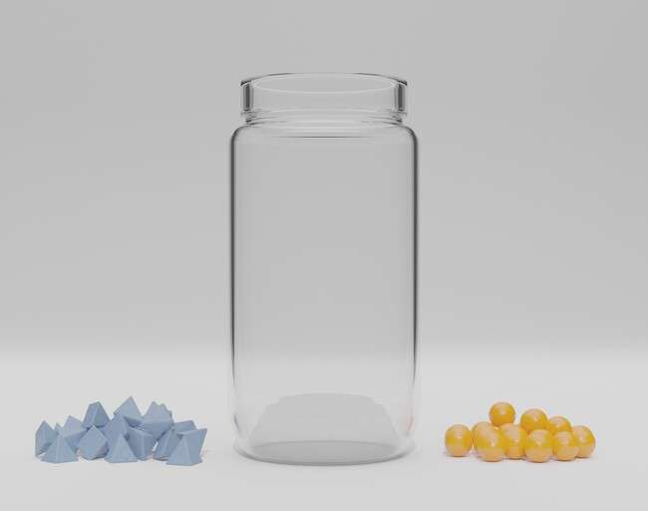

Images by Ben Austin

factors

Genetic vulnerability factors

An episode of mental illness happens when the jar fills to the top

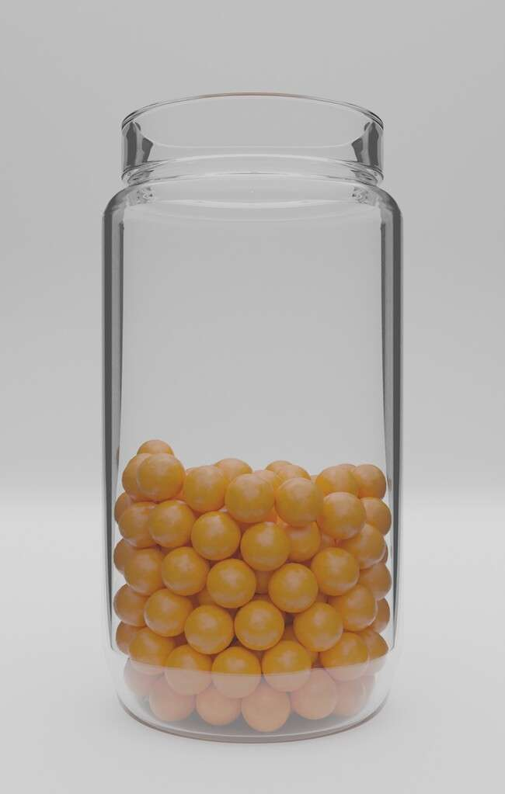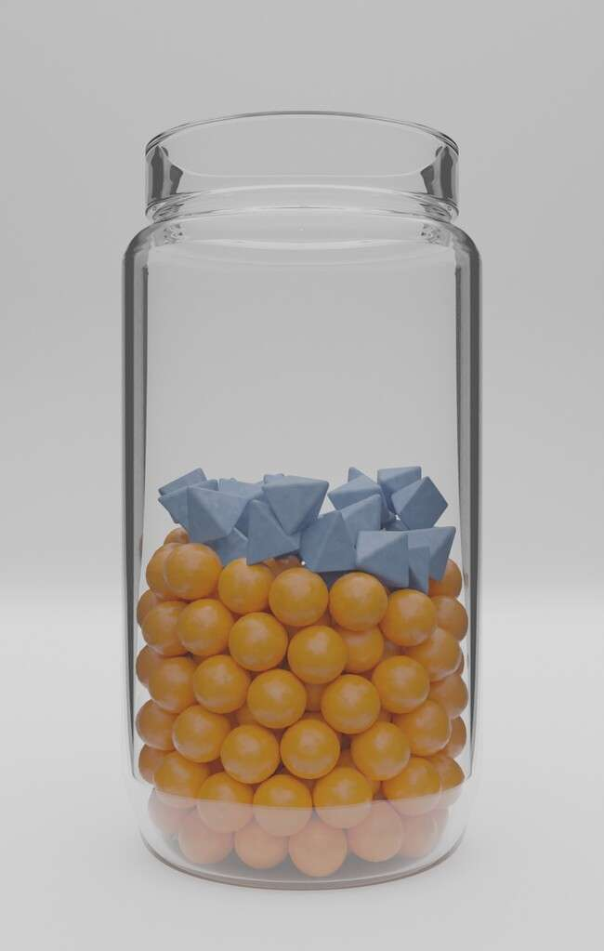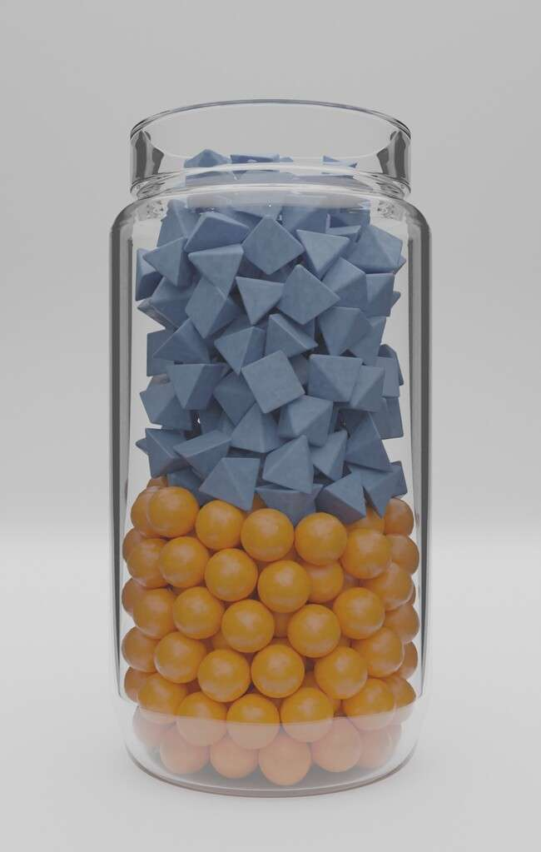

Time

Time

Images by Ben Austin

Mental illnesses can arise as a result of different combinations of genetic and environmental factors

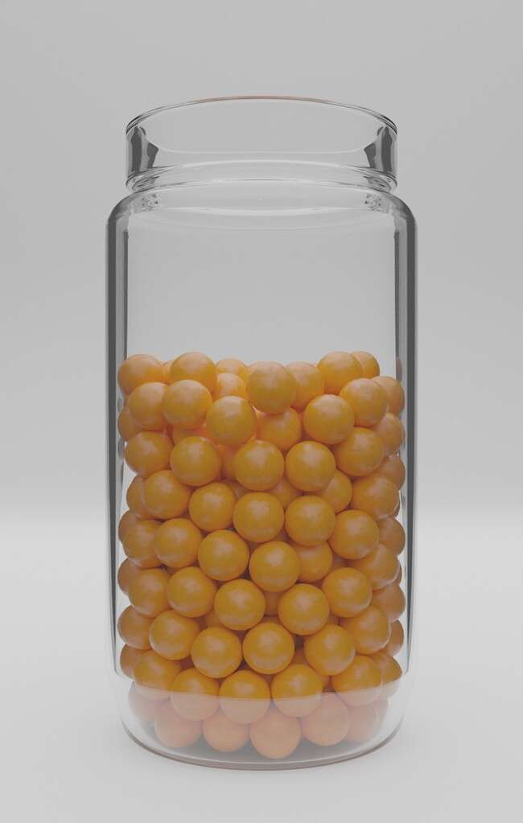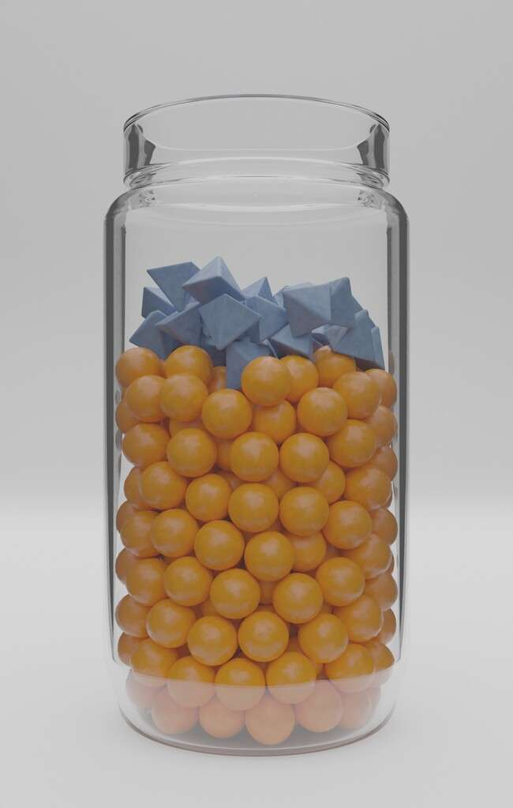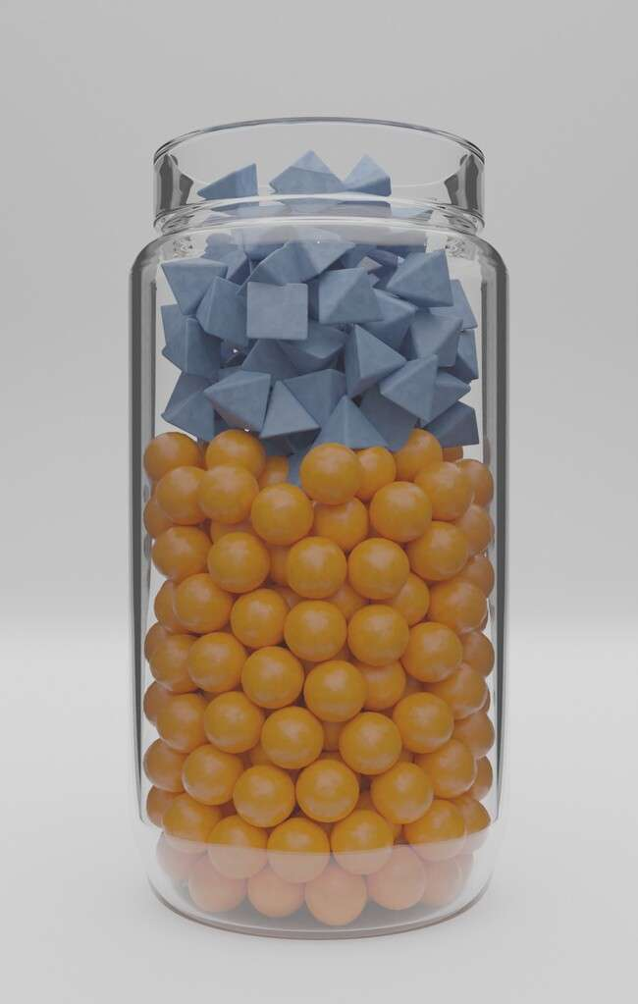

[Jehannine.austin@ubc.ca](mailto:Jehannine.austin@ubc.ca)

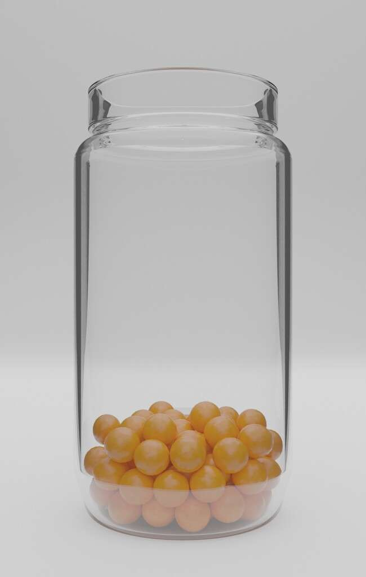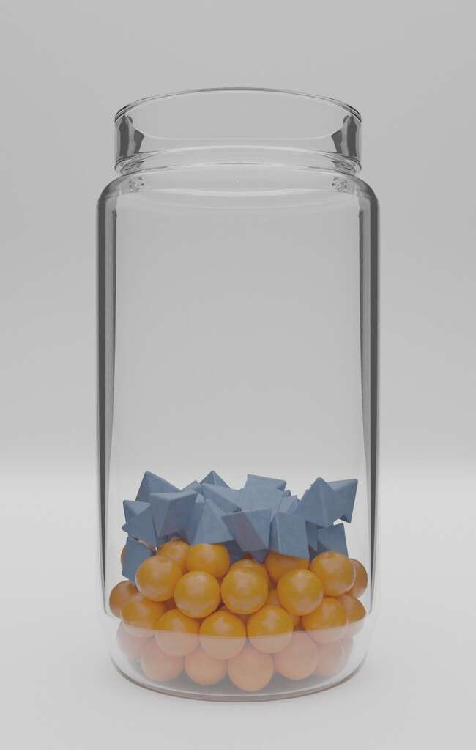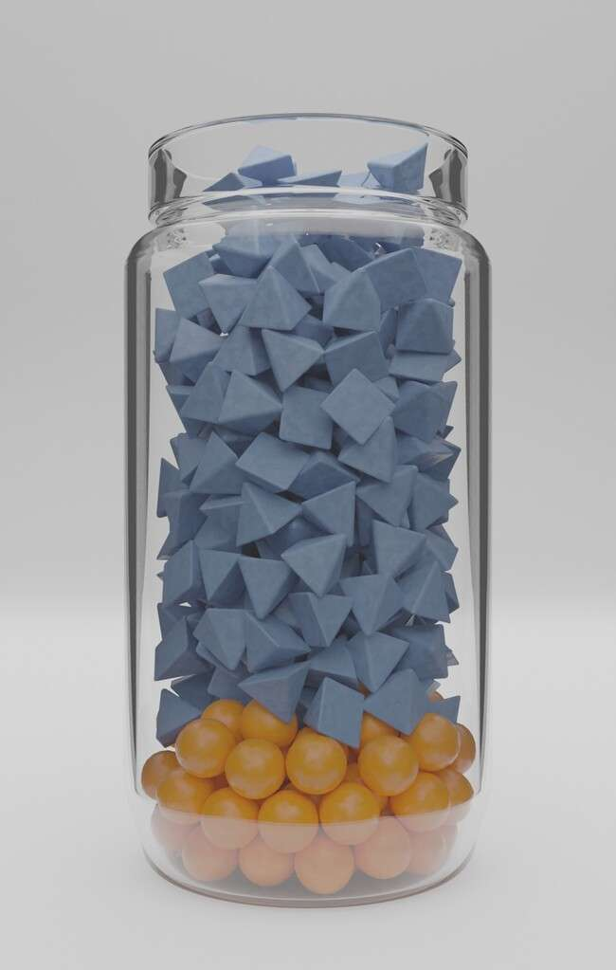

Images by Ben Austin

Everyone has some

genetic vulnerability to mental illness



[Jehannine.austin@ubc.ca](mailto:Jehannine.austin@ubc.ca)

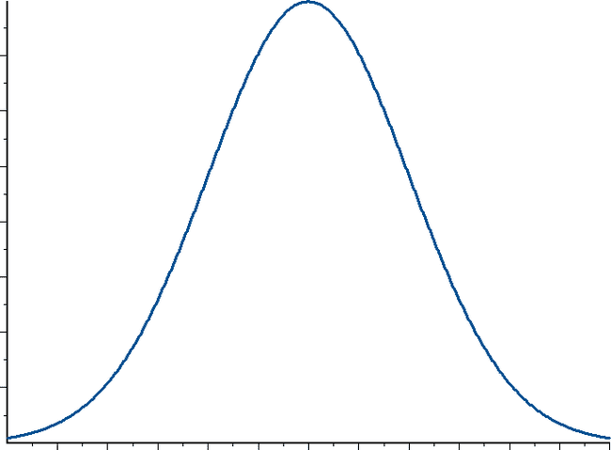

Low Risk

Moderate Risk

High Risk

Proportion of Population

We can inherit *vulnerability* to mental illness, not mental illness itself

[Jehannine.austin@ubc.ca](mailto:Jehannine.austin@ubc.ca)



Images by Ben Austin

We can have a lot of genetic vulnerability, but no mental illness



Images by Ben Austin

Protective factors can make a jar taller

Protective factors can stack on top of the jar to make it taller



Recovery from an episode of mental illness: making a jar taller with “protective factors”

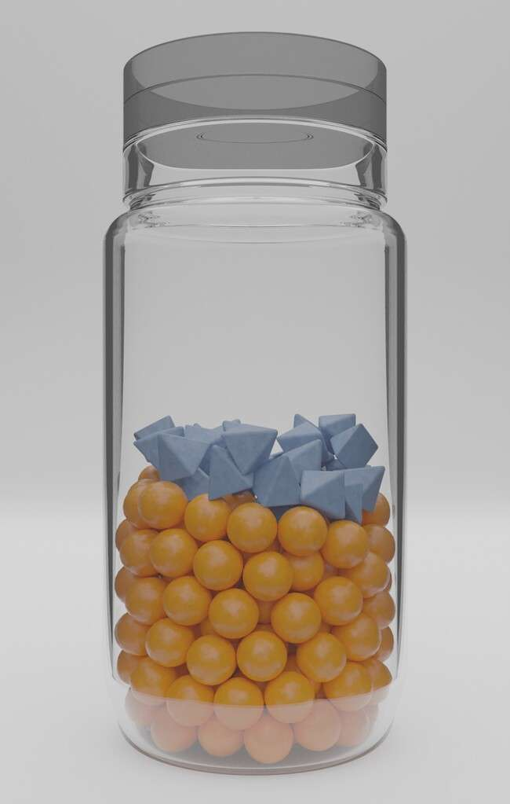

Images by Ben Austin

Protecting mental health before an episode of illness occurs



Images by Ben Austin

# CNV Mental illness jars

Everyone has a “mental illness jar”



Environmental vulnerability

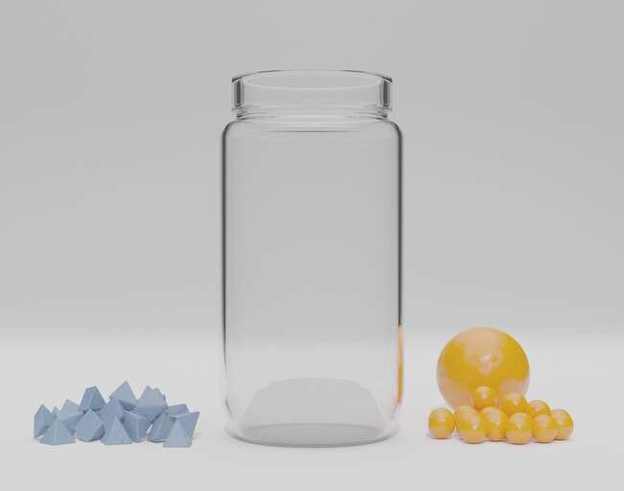

Images by Ben Austin

factors

Genetic vulnerability factors

An episode of mental illness happens when the jar fills to the top

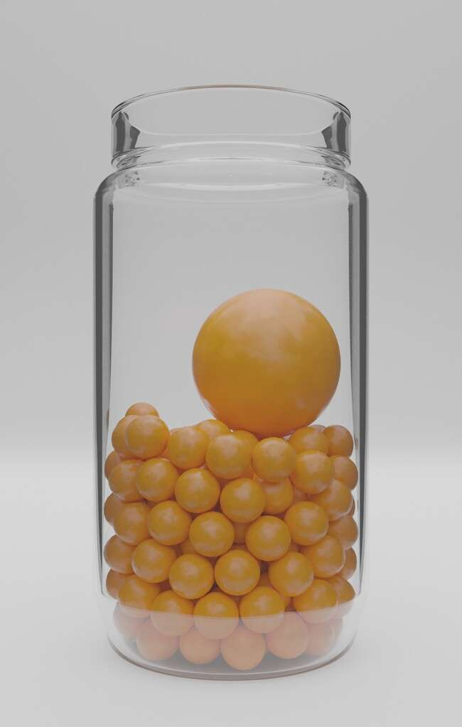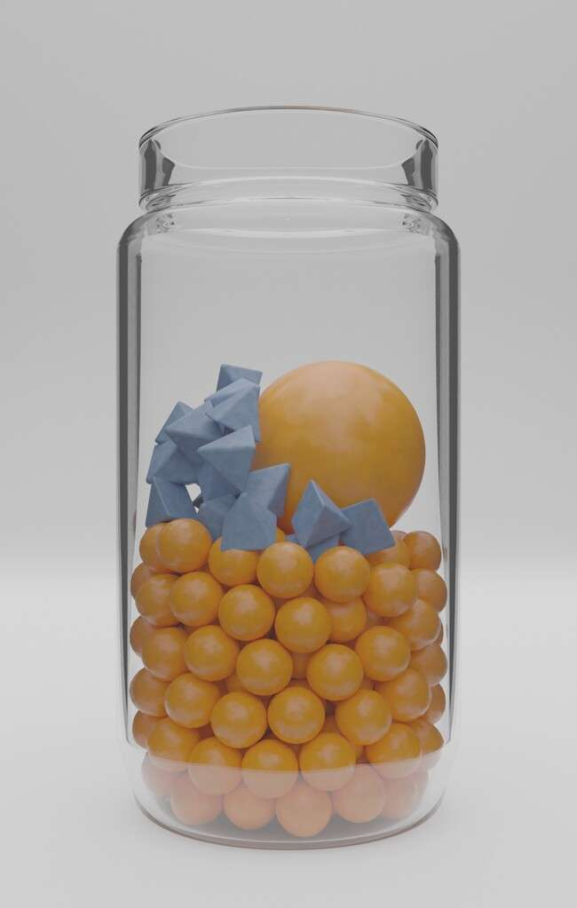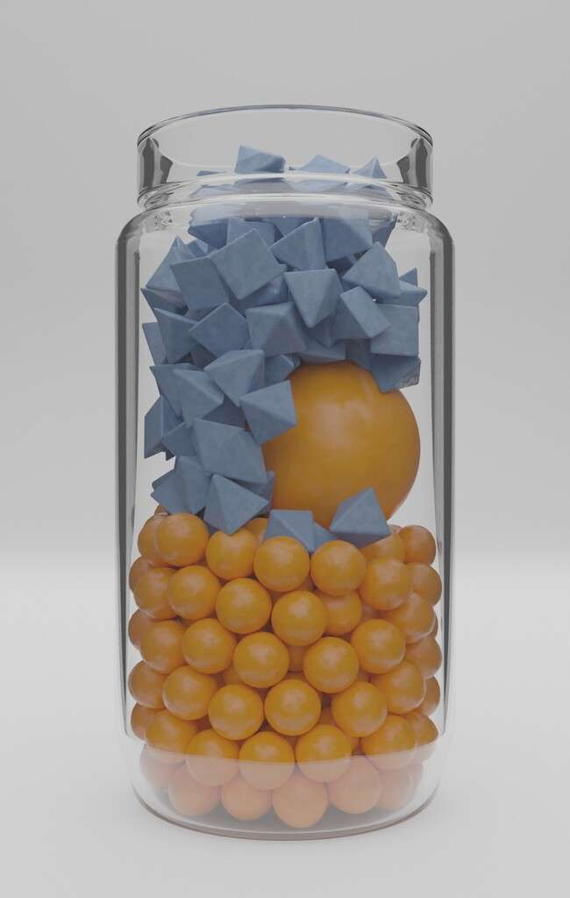

Images by Ben Austin

We can have a lot of genetic vulnerability, but no mental illness



Images by Ben Austin

Protective factors can make a jar taller

Protective factors can stack on top of the jar to make it taller



Recovery from an episode of mental illness: making a jar taller with “protective factors”

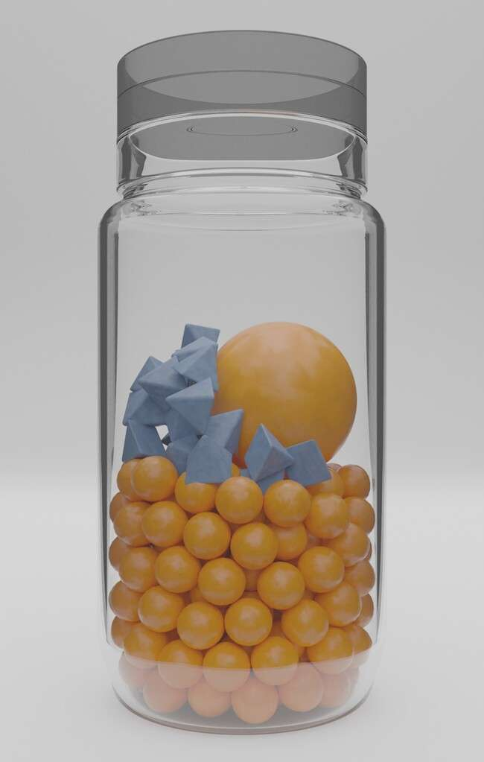

Images by Ben Austin

Protecting mental health before an episode of illness occurs



Images by Ben Austin

# Major events Mental illness jars

Everyone has a “mental illness jar”



Environmental vulnerability

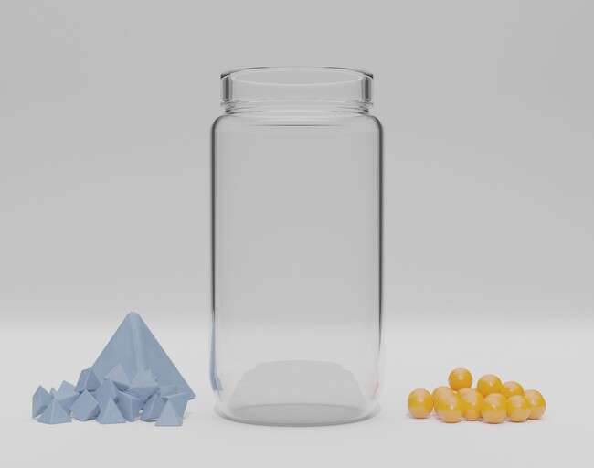

Images by Ben Austin

factors

Genetic vulnerability factors

An episode of mental illness happens when the jar fills to the top



Time

Time

Images by Ben Austin

Some events can have a big impact on our vulnerability

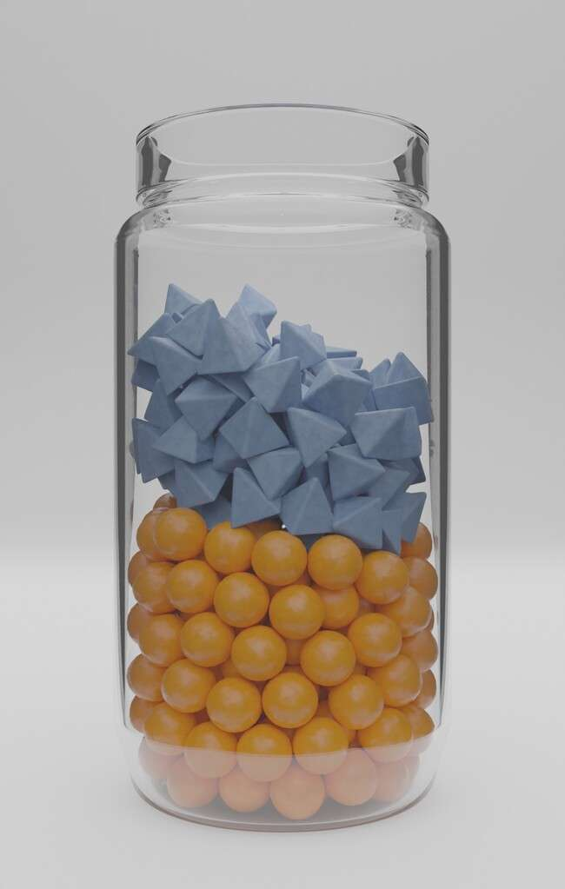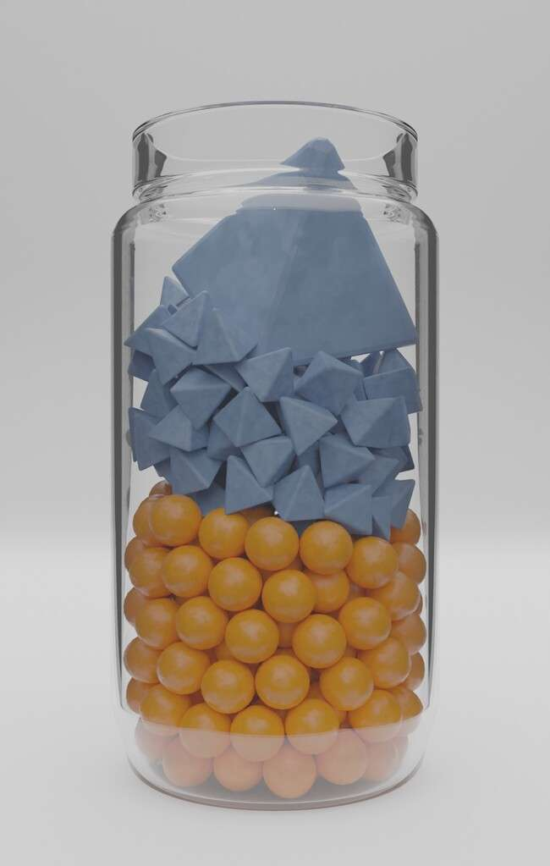

Images by Ben Austin

Protective factors can make a jar taller

Protective factors can stack on top of the jar to make it taller



Protecting mental health before an episode of illness occurs

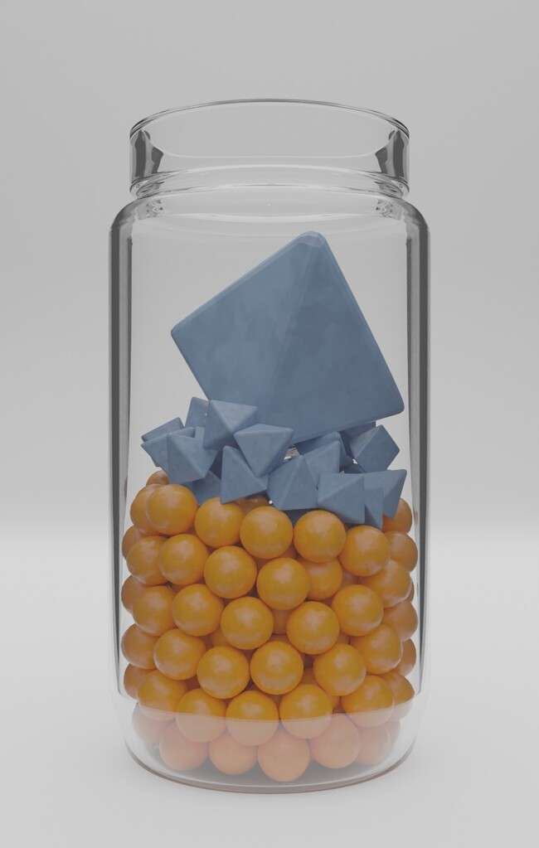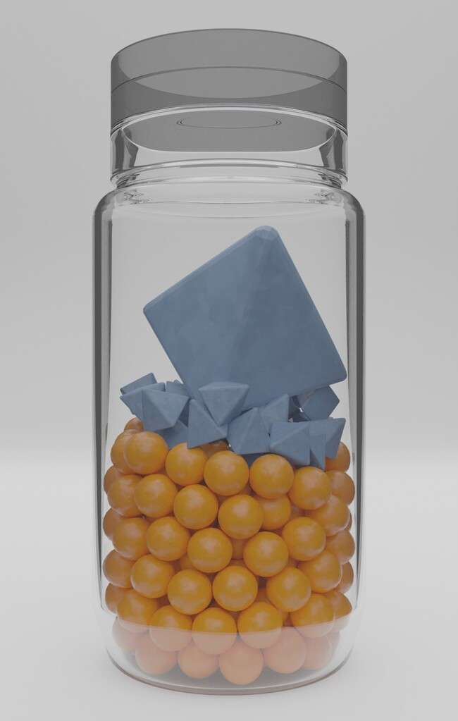

Images by Ben Austin

Recovery from an episode of mental illness: making a jar taller with “protective factors”

[Jehannine.austin@ubc.ca](mailto:Jehannine.austin@ubc.ca)

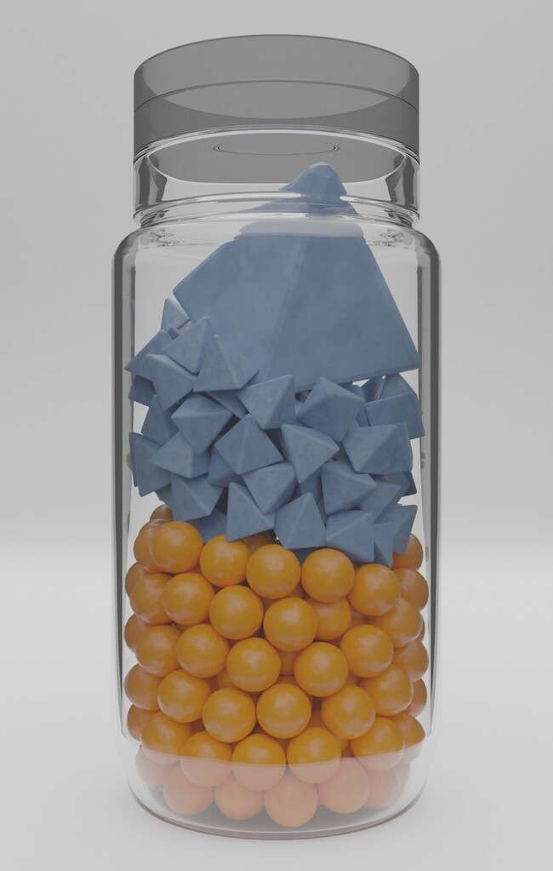

Images by Ben Austin

Gene x environment interaction Mental illness jars



For people with specific genetic factors, some environmental factors can have a bigger effect

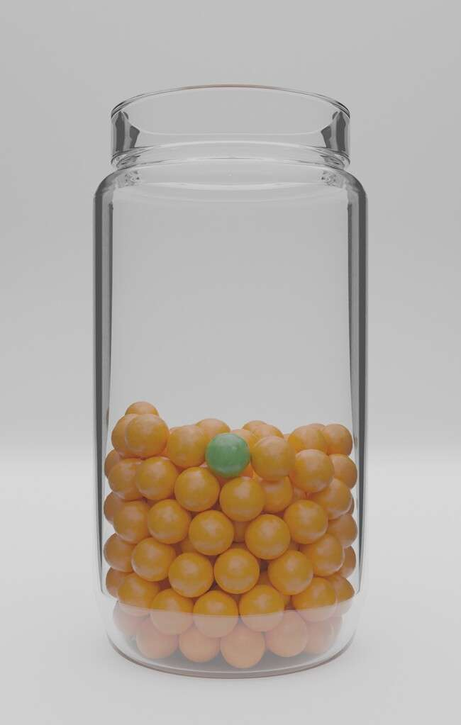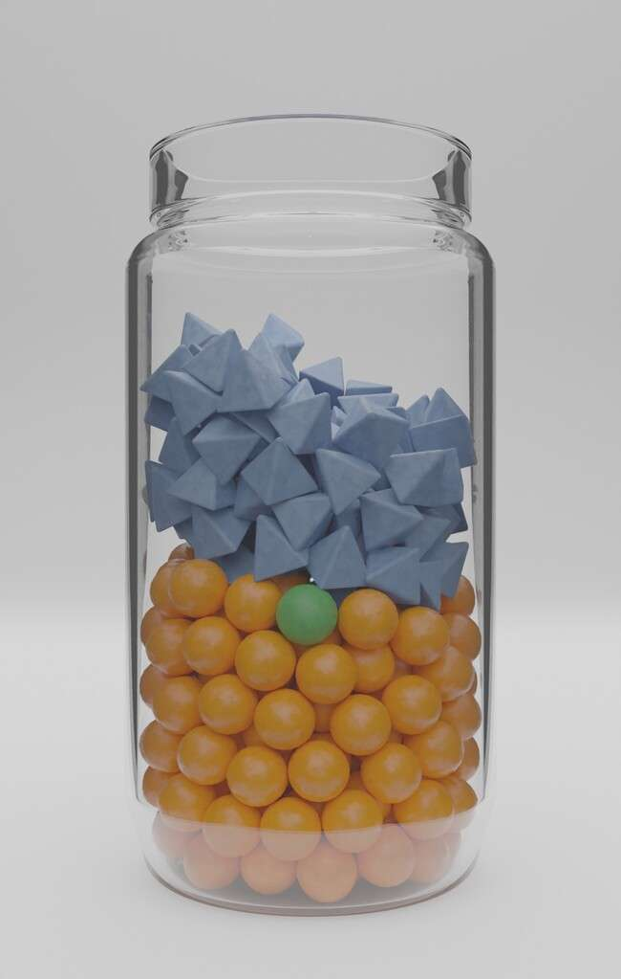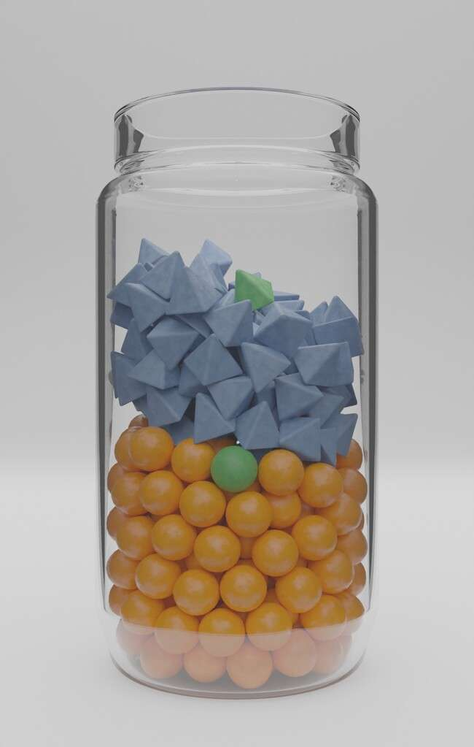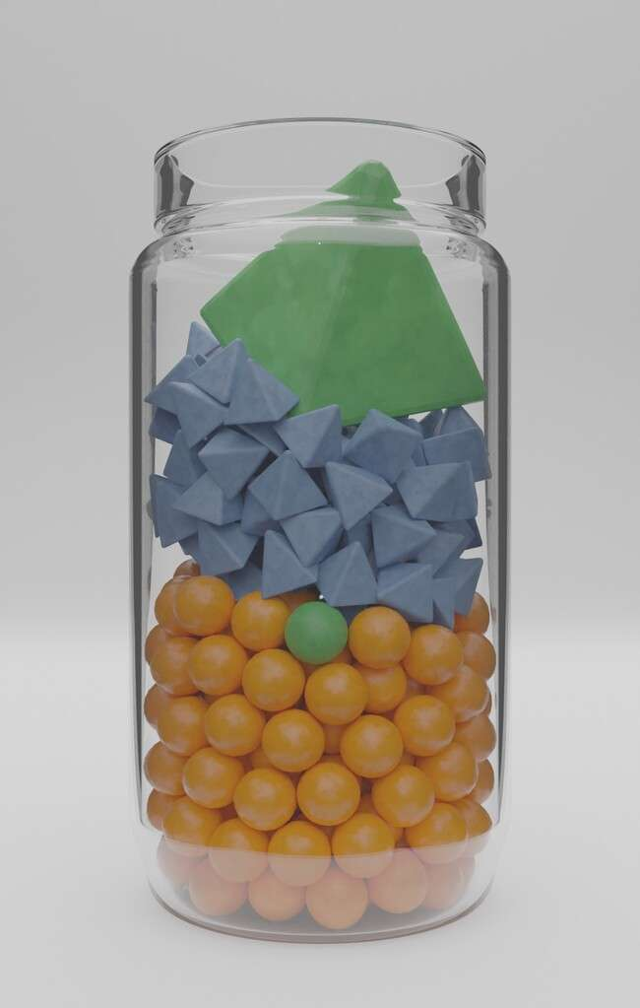

Images by Ben Austin



Some genetic factors can have a bigger effect in the presence of a particular environmental factor

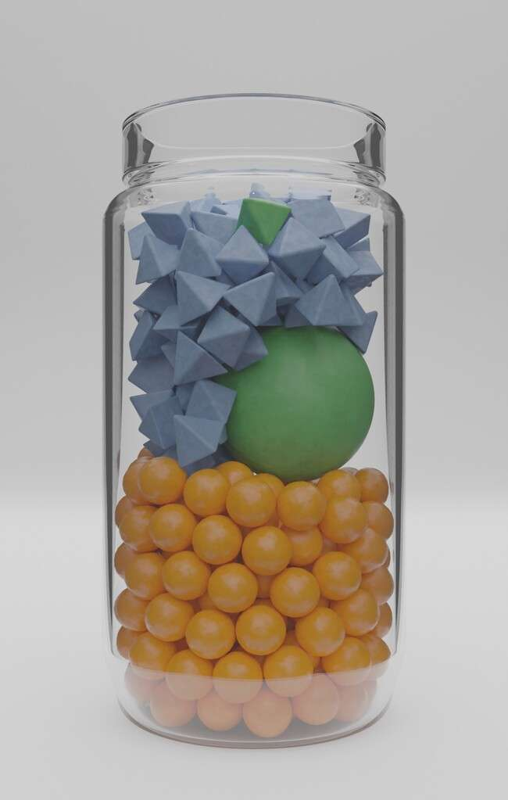

Images by Ben Austin

When a specific environmental exposure happens but the specific genetic factor is not present

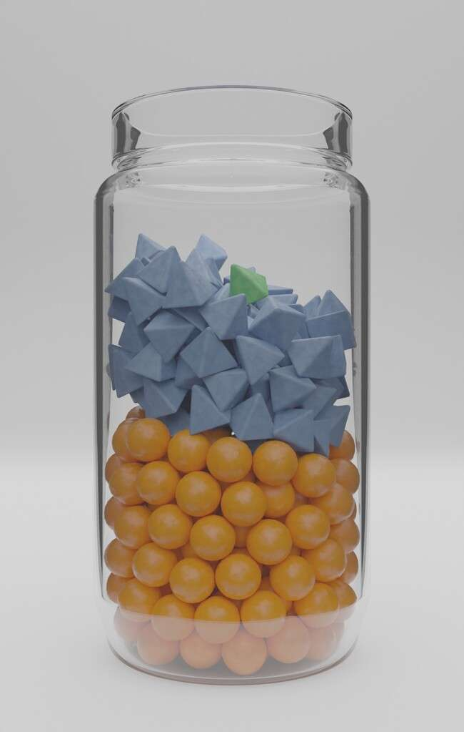

Images by Ben Austin

When a specific genetic factor is present, but the environmental exposure doesn’t happen



Images by Ben Austin

# PRS counseling



My genetic risk score for depression

My risk score

Number of people with this score



Increasing genetic risk for depression

This is how your genetic risk - according to the variations tested - compares to others’ risk from testing the same set of variations

What does my genetic risk score for depression mean?

Number of people with this score

|  |  |  |  |
| --- | --- | --- | --- |
| Z | A | B | C |

**Panels at the bottom of the page each represent 100 people. People in blue have depression. People in red do not. Each panel represents our BEST GUESS about the chance for someone to develop depression.**

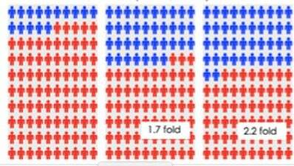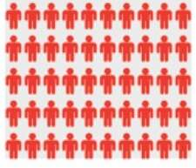

**Panel A: this represents the proportion of people general population who will experience depression during their life (15%, or 15 out of 100) – it is also the proportion of people whose PRS is in the range A who will experience depression during their life.**

**Panel B: this is the proportion of people (37%, or 37 out of 100) whose PRS is in range B who will experience depression during their life.**

**Panel C: this is the proportion of people (42%, or 42 out of 100) whose PRS is in range C who will experience depression during their life.**

**Panel Z: this is the proportion of people (10%, or 10 out of 100) whose PRS is in range Z who will experience depression during their life.**

Panel Z Panel A Panel B Panel C [Jehannine.austin@ubc.ca](mailto:Jehannine.austin@ubc.ca)

The chances for depression on the last page are only best guesses because the test only looked at a small proportion of all the factors (genetic & environmental) that can contribute to developing depression

There are lots of factors that can contribute to risk that were not tested

Combined, all of the genetic variations that were tested contribute this much to the total picture of why people develop depression.

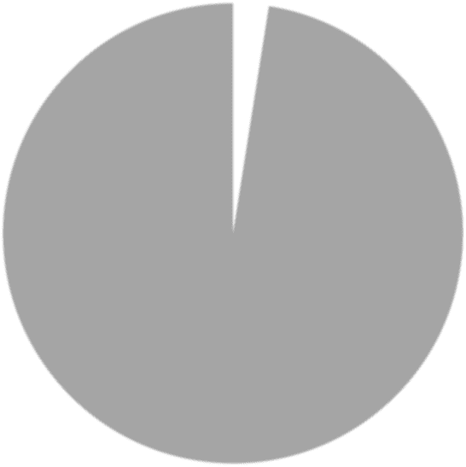

2.5%

97.5%



My risk score

Increasing genetic risk for depression

Number of people with this score

Things that can contribute to developing depression that were *not* tested for (including other genetic factors, & experiences).

The chances for depression on the last page are only best guesses because the test only looked at a small proportion of all the factors (genetic & environmental) that can contribute to developing depression

There are lots of factors that can contribute to risk that were not tested



Things that can contribute to developing depression that were *not* tested for

Combined, all of the genetic variations that were tested contribute this much



My risk score

Increasing genetic risk for depression

Number of people with this score